Part 1: Industrial robot
3.24.2.1 (ANSI/CSA added)
operating space
portion of the restricted space that is actually used while performing all motions commanded by the task program
[ISO 8373:1994, definition 4.8.3]
5.8.3 Enabling device
- When more than one enabling device is in operation (i.e. more than one person is in the safeguarded space with an enabling device), motion shall only be possible when each device is held in the center (enabled) position at the same time.
Note – (ANSI/CSA) this applies to enabling devices connected to one controller
Part 2: Industrial robot systems and integration
3.16 (ANSI/CSA added)
operator
the person or persons installing, operating (starting, monitoring, stopping the intended operation), adjusting, maintaining, cleaning, repairing, or moving machinery
Note - Person, persons, and personnel are used interchangeably with operator and operators.

3.17 (ANSI/CSA added)
industrial robot system
system comprising:
- industrial robot;
- end-effector(s);
- any machinery, equipment, devices, external auxiliary axes or sensors supporting the robot performing its task
NOTE – The robot system requirements, including those for controlling hazards, are contained in this part of the standard.
<Add definition for safety-related>
4.6 (ANSI/CSA) Assigned responsibilities
The risk assessment shall be performed by the integrator at the time of initial robot systems design to determine minimum safeguarding requirements and to develop an overall safety strategy. This assessment shall be revised and updated as the design process matures prior to delivery of the robot system to the user. The user shall provide information to assist in an integrator’s risk assessment to help determine actual requirements for the delivered system (see 4.4.2). The results of a task-based risk assessment covering relevant tasks and related hazards shall be provided in the information for use in accordance with 7.2. << add hook to results annex>>
The user shall perform a risk assessment in accordance with 4.3, or validate a risk assessment or results of a risk assessment provided for delivered equipment. The user shall maintain the documentation of the most recent risk assessment(s).
If any modification to the robot system is made that affects the identified hazards listed in the information for use, then a risk assessment shall be performed. If modifications create additional hazards, these hazards shall be included in the risk assessment for review.
Minimum requirements for a risk assessment and a recommended methodology can be found in Annex NA. A number of methodologies are available to do a risk assessment. Any method is acceptable which prescribes safeguarding equivalent to or more stringent than the results obtained by the use of Annex NA. The risk assessment methodology shall contain at a minimum the following elements:
- Establish risk level estimation
- Relationship between risk level and risk reduction measure selection
- Fixed relationship between risk level and circuit performance (functional safety)
5 Safety requirements and protective measures
5.1.1 (ANSI/CSA) User responsibilities
The user shall be responsible for complying with Part 2 of this standard for any associated equipment added or installed by them when the user is essentially functioning as the integrator/installer. This includes component additions, modifications, assembly of partly completed machinery, implemented revisions to specifications or machine designs done by or required by the user.
The user shall ensure that any person who programs, teaches, operates, or maintains robots or robot systems or associated equipment in a robot cell is trained on safety issues and procedures related to assigned tasks.
NOTE – This training is best presented when integrated with operational training.
5.2.2 Performance requirement
NOTE 2 – (ANSI/CSA) Compliance with a) thru d) meets the requirement of “control reliable” as used in North America.
5.3.6.1 (ANSI/CSA) User requirements
The user shall ensure compliance with NFPA 79. and NFPA 70E or CSA Z462 for all installation requirements.
The user shall provide necessary means to comply with requirements for control of hazardous energy as specified in ANSI Z244.1 or CSA Z460 for any additional equipment which the user supplies or installs.
The user shall develop necessary written procedures and personnel training programs to comply with ANSI Z244.1 or CSA Z460.
5.3.8.2 Emergency stop function
The actuation of an emergency stop function shall stop all robot motion and other hazardous functions in the cell, [and or] at the interface between cells and other areas of the workspace.
Note – should read the cell, and at the
NOTE (ANSI/CSA) – If a detachable/wireless pendant is considered the control station see 5.7.1.1.
5.3.8.2.1 (ANSI/CSA) Emergency stop function
When emergency stop functions are provided by rope/cable pull or push-bar operated type emergency-stop devices, the devices shall be selected and installed to:
- provide a latching function that requires a manual reset after actuation;
- have direct opening operation (reference IEC 60947-5-5);
- detect a slack condition or a break of the rope/ cable;
- have the capability to react to a force in any direction;
- have an actuator that is red in color;
- have an actuator that withstands its intended use.
The emergency stop device shall remain unguarded and be easily accessed from an operator work station
5.3.8.3 Protective stop
NOTE (ANSI/CSA) – If any safety related function is automatically bypassed, the automatic bypass is also a safety related function to which compliance with clause 5.2.2 is applicable.
5.3.11.1 (ANSI/CSA) User requirements
The user shall develop and provide the necessary training in the fault recovery of the robot system and related equipment.
5.3.12.1 (ANSI/CSA) User requirements
The user shall be responsible for installing any necessary signs or labels as called out in information for use.
5.3.15.1 (ANSI/CSA) Use instructions
When a person is required to be protected within the safeguarded space using an enabling device, the user shall provide instructions and training to personnel in the proper functionality and use of the enabling device.
5.3.15.2 (ANSI/CSA) Additional hazard consideration
Care should be taken to consider non-robotic sources of hazards (e.g. standing in the motion-range of auxiliary equipment while attending to other equipment) during manual operation.
5.3.16 (ANSI/CSA) User responsibilities
The user shall ensure that all equipment and necessary utilities are installed in accordance with manufacturer specifications and instructions and in accordance with any regulatory and/or local requirements.
The user shall develop operating procedures (including necessary emergency procedures) and training programs based on information for use provided by the respective suppliers of equipment.
NOTE – Procedures, training and personal protective equipment can also be needed for abnormal and emergency situations.
5.4.2.1 (ANSI/CSA) User requirements
The user should conspicuously identify the restricted space(s); e.g. placards, marking on floor.
5.4.3 Means for limiting motion
NOTE 5 – (ANSI/CSA) If the perimeter guard is used as the limiting device; the specifications resulting from the testing or analysis that demonstrates that the guard will contain the hazard(s) within the parameters given should be provided in the information for use.
5.5.2 Access for interventions
- abidance and observation areas;
NOTE – (ANSI/CSA) areas that are designated for safe standing while performing tasks or observing tasks
5.5.4.1 (ANSI/CSA) User requirements
Process observation is intended for short term viewing of the robot system operation.
When process observation is required to be performed inside the safeguarded space, the user shall ensure that:
- personnel performing process observation are trained in the intended task;
- only necessary personnel shall be allowed within the safeguarded space during process observation;
- a means to prevent or warn against additional personnel entering the safeguarded space shall be provided;
- safeguarding and control measures have been utilized, procedures alone are insufficient (see also 5.3.15);
- when process observation has not been planned in the design and implementation of the robot system, the guidance in Annex F shall be followed prior to implementing any temporary means;
- management review/permission e.g. hot work permits.
5.6.3.1.1 (ANSI/CSA) User requirements
The user shall develop procedures and train personnel as to how to change modes and initiate operation in accordance with requirements in this standard.
5.6.4.3.1 (ANSI/CSA) Added requirements
The pendant shall comply with Part 1, 5.7.4. The user shall ensure this mode is not used for production. The user shall ensure that the operator functionally tests and uses the provided pendant while in this mode. The user shall develop procedures and training if manual high-speed mode is provided or readily available. The training shall include, for example instructions such as standing outside the robots operating space and operating the first test cycle at slow speed.
5.6.5 Remote access for manual intervention
- if no-one is in the safeguarded space and safeguards are active, remote functions may be performed without any local activities;
NOTE 1 (ANSI/CSA) – This means that no local acknowledgement is required for the remote operator to perform diagnostics, technical consultation, and testing.
- any equipment not needed for the remote action that could create a hazard shall be maintained in a safe state.
NOTE 2 (ANSI/CSA) – Safe state means locked out in accordance with ANSI/ASSE Z244.1 or CSA Z460.
- (ANSI/CSA) the decision to have an operator inside the safeguarded space during remote operation shall only occur after complying with the following:
- the remote operator and the local operator shall be in direct communication with each other, and the order of hierarchy of controls:
- the operator shall work outside, not in the safeguarded space. If this is not practicable, then
- limit the number of operators to one except in extraordinary cases. If this is an extraordinary case and it is not practicable to only have one person in the safeguarded space, then
- only one robot system shall be allowed, by control means, to move/operate unless following simultaneous motion (Part 1, 5.9)
5.6.6 (ANSI/CSA) User requirements
The user shall develop necessary written safe work practices and provide necessary training to personnel operating and working on robots and robot systems.
5.7.1.1 (ANSI/CSA) User requirements
The user shall ensure that proper storage for detached or cableless pendants is used to prevent the potential of an inactive emergency stop device from being relied upon in operations.
5.8.3.1 (ANSI/CSA) Restart interlock limitation
Movable guards should be interlocked. Clearing the field of an electro-sensitive protective equipment (ESPE) shall not initiate a starting command. Additional measures are also required if it is possible to remain in the safeguarded area by passing through the field of an ESPE. If a restart interlock in conjunction with presence sensing is provided, then, depending on the risk assessment, the presence-sensing device shall meet at a minimum the requirements of 5.2.2, unless the risk assessment determines another performance criterion is appropriate.
5.8.5 (ANSI/CSA) User requirements
The user shall be responsible for following instructions contained in information for use to establish a maintenance program as required for the continued safe operation of the installed equipment. The user should be able to demonstrate that an effective inspection and maintenance program is in place. The inspection and maintenance program shall consider the recommendations of the manufacturer of the robot or the robot system and local application specific requirements. When safe work procedures and training are required, the user shall develop and provide necessary procedures and training.
5.9.1 General
NOTE – (ANSI/CSA) The first sentence above should read: “Other machinery and equipment that is associated with the robot system but not directly controlled by the robot controller, the zoning configurations, safeguarding and span of control implementation as presented in ISO 11161, shall be included in the risk assessment.”
5.9.8 (ANSI/CSA) User requirements
The user shall develop necessary safe work procedures and training programs to ensure any personnel are trained on the applicable span of control of any emergency stops and other protective devices. Identification of span of control for all safety-related controls shall be conspicuously displayed if the span of control of the emergency stop does not include the entire cell.
5.10.1.1 (ANSI/CSA) User requirements
The user is responsible for complying with 5.10 for any equipment added or changed by them associated with the robot system provided.
5.10.4.2 General requirements for fixed distance guards
NOTE 1 (ANSI/CSA) – The hazard of robot motion can be anywhere within the restricted space. Hazards presented by other equipment can exist anywhere within the safeguarded space.
NOTE 2 – (ANSI/CSA) ISO 13857 states that a height greater than 180 mm (7 inches) can allow whole body access. The bottom of the guard may be no greater than 150 mm (6 inches) above the walking surface to prevent access.
NOTE 3 – (CSA) The top of the guard may be no less than 1800 mm (72 inches) above the walking surface to prevent access.
5.10.4.3 General requirements for interlocked movable guards
NOTE – (ANSI/CSA) These guards may only be used where there is no possibility of whole body access. See B11.19 and CSA Z432 for additional information on interlocked movable barrier devices.
5.10.4.4.1 (ANSI/CSA) Guard locking requirement
The guard locking function shall comply with the requirements of 5.2.2, unless the risk assessment determines another safety performance.
5.10.5.2 Sensitive protective equipment used to initiate a protective stop
- when the sensitive protective equipment is reset, the hazardous conditions being safeguarded by the sensitive protective equipment can operate, but the reset of the sensitive protective equipment does not by itself initiate their operation.
- (ANSI/CSA) Sub-clause c) is superseded for presence sensing device initiation (PSDI) when implemented by 5.10.5.4.
5.10.5.2.1 (ANSI/CSA) Perimeter Safeguards Using Electro-Sensitive Protective Equipment
The perimeter safeguarding shall not be installed closer to the hazard than the restricted space. The installation shall take into account the minimum (safe) distance in accordance with 5.10.3.3, which shall also include the depth penetration factor. The same ESPE shall not be used as a limiting device and function as a perimeter safeguard. Single beam ESPE shall not be used for perimeter safeguarding.
NOTE 1 – ESPEs used as limiting devices cannot meet the safety distance requirements of a safeguard since the robot will penetrate the ESPE sensing plane.
Unless additional safeguarding devices are installed to prevent or detect access to the hazard, the perimeter safeguarding shall be positioned so that:
- As measured from the adjacent walking surface, the bottom of the ESPE shall be no higher than:
- CSA: 150 mm (6 in)
- ANSI: 300 mm (12 in)
- With an opening to the bottom of the perimeter ESPE being greater than 95 mm (3.7 in), there shall be no floor level hazards within sweep of 1100 mm (43 in) of the bottom of the perimeter ESPE. An opening of this size could allow a leg to access 1100 mm (43 in) into the safeguarded space. If there are hazards located closer than 1100 m (43 in), the opening between the walking surface and the perimeter ESPE shall be decreased to comply with the Table in Annex NB.
NOTE 2 – ISO 13857-2008 requires a maximum height of 0.30m (12 in).
- As measured from the adjacent walking surface, the top of the ESPE shall be at least 0.9m (36 in) with a Dpf / C of 1.2m (48 in). If the ESPE is greater than 0.9m (36 in) in height, the Dpf / C shall be determined by ESPE coverage height and the height of the closest hazard, in accordance with Annex NB.
NOTE 3 – ANSI/CSA) CSA Z434-03 required a minimum height of 6 ft and ISO 13855-2010 allows various heights depending on the height of the hazard. ISO 13855-2010 requires a Cro (Dpf when reaching over the ESPE). This Cro (Dpf) is based on the height of the ESPE coverage and the height of the hazard.
- If there is a possibility of projectiles exiting the safeguarded space, ESPEs shall not be used.
NOTE 4 –ESPEs could be used if the robot end-effectors are equipped with effective part retention hardware such as locking or over center closing clamps.
NOTE 5 –See 5.10.3.2 for information about the use of fixed guards used as a perimeter safeguard.
NOTE 6 –See 5.10.2 for information about perimeter guards.
5.10.5.4 (ANSI/CSA) ESPE equipment used for PSDI
Presence Sensing Device Initiation (PSDI) is the type of operation used during automatic mode when an electro-sensitive protective equipment (ESPE) acts as a safeguarding device, and is also used in a control configuration such that any interruption(s) of or intrusion(s) into the detection field is detected and monitored. The PSDI portion of the safety-related control system initiates a cycle start when the sensing field clears after the detected intrusion without the need of separate manual action to enable the cycle.
NOTE 1 – The PSDI portion of the safety-related control system can be within the ESPE control system or an external safety control system.
The robot system shall be designed consistent with the results of a risk assessment and consideration of the cell layout for PSDI and implemented such that the following additional requirements are met when a presence sensing safety device is used to signal a start action in addition to its safeguarding function:
- PSDI shall be used for production operations only, and only on equipment which can be stopped anywhere in the hazardous portion of its cycle. Setup, teaching, and maintenance shall not be done while PSDI functions are active;
- a configuration which would allow a person to enter, pass through towards the hazardous area and become undetected by the ESPE’s sensing field shall not be used in a PSDI mode of operation;
NOTE 2 - Careful consideration is needed if PSDI is to be used in the horizontal sensing plane.
NOTE 3 - The direction of an operator’s travel in the ESPE sensing field can be monitored by multiple zone sequencing or by monitoring the sequencing of multiple ESPE’s.
- PSDI shall comply with the following:
1) for robot systems that are able to operate with and without PSDI, selection of PSDI operation shall require a separate and deliberate act;
2) cells shall be clearly identified that PSDI is being used in production;
3) be used for short cycle time tasks;
4) pressure-sensitive devices shall not used for the cycle initiation;
5) a timer shall be provided to deactivate PSDI should there be a delay between production initiations commensurate with normal cycle time;
6) for robot systems designed to pick and release parts or workpieces, part-in-place sensing shall be used, such that the proper condition (with part or without part) is detected in order for PSDI to operate;
7) where more than one ESPE device exists, only one device may cycle initiate;
8) mirrors shall not be used for the purpose of PSDI;
9) only initiates a single machine cycle/sequence;
10) cells using double break supervisory control shall display status of breaks, and include information for use of the controls;
NOTE 2 – PSDI Single break means that a single ESPE field intrusion and clearing of the field will result in PSDI cycle initiation. Double break means that there are two instances of intruding and clearing before cycle initiation. Double break is typically used for handling large parts.
EXAMPLE – The operator reaches through the ESPE field and removes the “finished” part (break one). The operator then picks up the “unfinished” part and reaches through the ESPE field to load it. When the operator withdraws their hands from the ESPE field (second break of the field), the PSDI safety control logic initiates the cycle to start.
11) when any protective stop command is issued for safeguarding purposes (i.e. stopping the robot system cycle), a manual or conscious act shall be required to re-initiate the robot system cycle;
- the ESPE used during PSDI automatic operation shall:
1) meet at least the requirements of 5.2.2 for the functional safety of the safety related parts of the controls
2) have at least 30mm object sensitivity according to ISO 13855
3) light curtains used for PSDI operation shall have a minimum object sensitivity not to exceed 30 mm (1.25 in)
NOTE 3 – It is possible that ESPEs with a resolution greater than 30 mm (1¼ in) to not detect the wrist or the lower arm after the hand has been detected. If this happened, an unexpected cycle re-initiation can occur.
4) Where light curtain object sensitivity is user-adjustable, either discretely or continuously, design features shall limit the minimum object sensitivity adjustment not to exceed 30 mm.
- If Fixed Blanking is used, then the blanked area shall be completely obstructed. Floating Blanking shall not be used if the minimum object sensitivity exceeds 30 mm in such use;
1) shall not be defeatable by using improper object sensitivity.
2) all other access to the hazard shall be prevented or safeguarded with additional ESPE that are not operating in PSDI.
5.10.6.1 General
NOTE – (ANSI/CSA) The work station should be designed for ease of operation without introducing hazards not associated with the basic work task.
5.10.6.3 Additional requirements for manual stations with a shared workspace
NOTE (ANSI/CSA) – If muting is used, see Muting, clause 5.10.10
5.10.6.3.1 (ANSI/CSA) Preventing inadvertent resetting
Presence-sensing shall be used, but if presence-sensing is not practicable, then a restart interlock shall be provided to prevent inadvertent resetting of the restart interlock. This will prevent the robot system from moving into the workspace while the operator remains in the workspace.
5.10.6.3.2 (CSA) PSDI in shared workspace
PSDI shall not be used in a shared workspace.
5.10.8.1 (ANSI/CSA) Suspension of a safety-related function
When the safety function of the protective device(s) is suspended (bypassed), then alternate effective safeguarding shall be provided. If the suspension is by a controlled means, this means shall meet the required safety performance of 5.2.2, unless a risk assessment determines that another performance criterion is appropriate. If the suspension is by a manual means, the user shall establish procedures to warn operators, ensure that the suspension is temporary, and provide training about the suspension (bypass).
5.10.10 Muting
NOTE (ANSI/CSA) – The requirement for detection refers to implementations where the person is allowed and expected to be in the hazardous zone during muting.
NOTE (ANSI/CSA) – See clause 5.10.7 Material Entry/Exit for situations when only material enters or exits the safeguarded space.
NOTE – (ANSI/CSA) The information for use should include warnings of residual risk if identifiable misuse of whole body access could be achieved during the muting cycle.
5.10.10.1 (ANSI/CSA) User requirements
Operators shall be trained to understand muting, the indicators (if any), how it is used in the robot system / cell, and of needed verification procedures.
5.10.11 Suspension of safeguards
The selection of the mode of operation shall be by secure means (e.g. by a lockable selection device, password, access code) and shall meet the requirements of 5.2.2. [(ANSI/CSA) The means shall meet the same performance level as the safeguard(s) being suspended.]
The integrator shall provide information for use for critical situations when it is necessary to manually suspend safeguards, e.g. troubleshooting [fault recovery, setting safety-related sof axis and space limits, replacing hard stops,] and exchange of a safeguarding device.
5.10.11.1 (ANSI/CSA) User requirements
The personnel, particularly the teacher, shall be trained in what protective devices are automatically suspended during manual operation and what additional protective measures are necessary.
The user shall provide and install appropriate temporary (interim) protective measures when installed protective devices are manually suspended including clear indications that such temporary measures have been applied.
Personnel returning suspended protective devices to service shall check to ensure they are properly functioning prior to initiating automatic operation of the system.
5.11.1.1 (ANSI/CSA) User requirements
The user shall ensure that the information for use is followed for selection and installation of proper safeguarding during collaborative operation and develop applicable safe work procedures.
The user shall ensure that personnel who will operate collaborative robots are properly trained in procedures and the operation of the robot system.
5.11.2 General requirements
- Robots integrated into a collaborative workspace shall meet the requirements of Part 1. (ANSI/CSA) This includes in particular Part 1 Clause 5.10.
5.11.5.1 General
(ANSI/CSA) Robots used in collaborative operations described in 5.11.5.3 to 5.11.5.5 shall additionally comply with safe motion features defined in Part 1, Clause 5.12.3.
5.11.5.3 Hand guiding
- when the operator releases the [enabling device on the] guiding device, a safety-rated monitored stop in accordance with Part 1 is issued.
6.1.1 (ANSI/CSA) User responsibilities
When the user modifies the robot system(s) or component thereof or otherwise acts as the integrator, the user is responsible for determining from the risk assessment what actions and methods in this clause are applicable for complying with the verification and validation requirements in this clause.
7.2.4 Information for commissioning test or initial start-up procedure
The commissioning test or initial start-up procedures should also be performed after completion of any maintenance task or system modification that could affect the integrity of the robot system(s) as designed and installed.
Note (ANSI/CSA) – Integrity is meant to refer to the safety integrity of the robot system.
7.2.5 System information
Information relating to the robot system itself shall include, for example:
- (ANSI/CSA) record of testing or analysis of any barrier used as a limiting device
8 (ANSI/CSA) Safety training of personnel
The user shall ensure that any person who programs, teaches, operates, or maintains robots or robot systems or associated equipment in a robot cell is trained on safety issues related to assigned tasks.
NOTE – This training is best presented when integrated with operational training.
8.1 Training objectives
The objective of a training program is to provide information on:
- the purpose of safety devices and their function;
- procedures, specifically those dealing with health and safety;
- hazards presented by and capabilities of the robot or robot system;
- tasks associated with a specific robot and application;
- safety concepts.
8.2 Training requirements
Training may be accomplished through classroom training, on the job training, or a combination of both. Training documentation will include at a minimum a description of the training, attendees, and date conducted. See annex ND for suggested course content.
8.3 Retraining requirements
Retraining shall be provided to include system changes and assure safe operation.
NOTE – These changes may include, but are not limited to:
- personnel changes
- system changes
- after an accident.

Annex NC
Graphical Aides to Understanding Space and Motion

A revision and update to the information currently contained in Annex A of the 1999 edition.
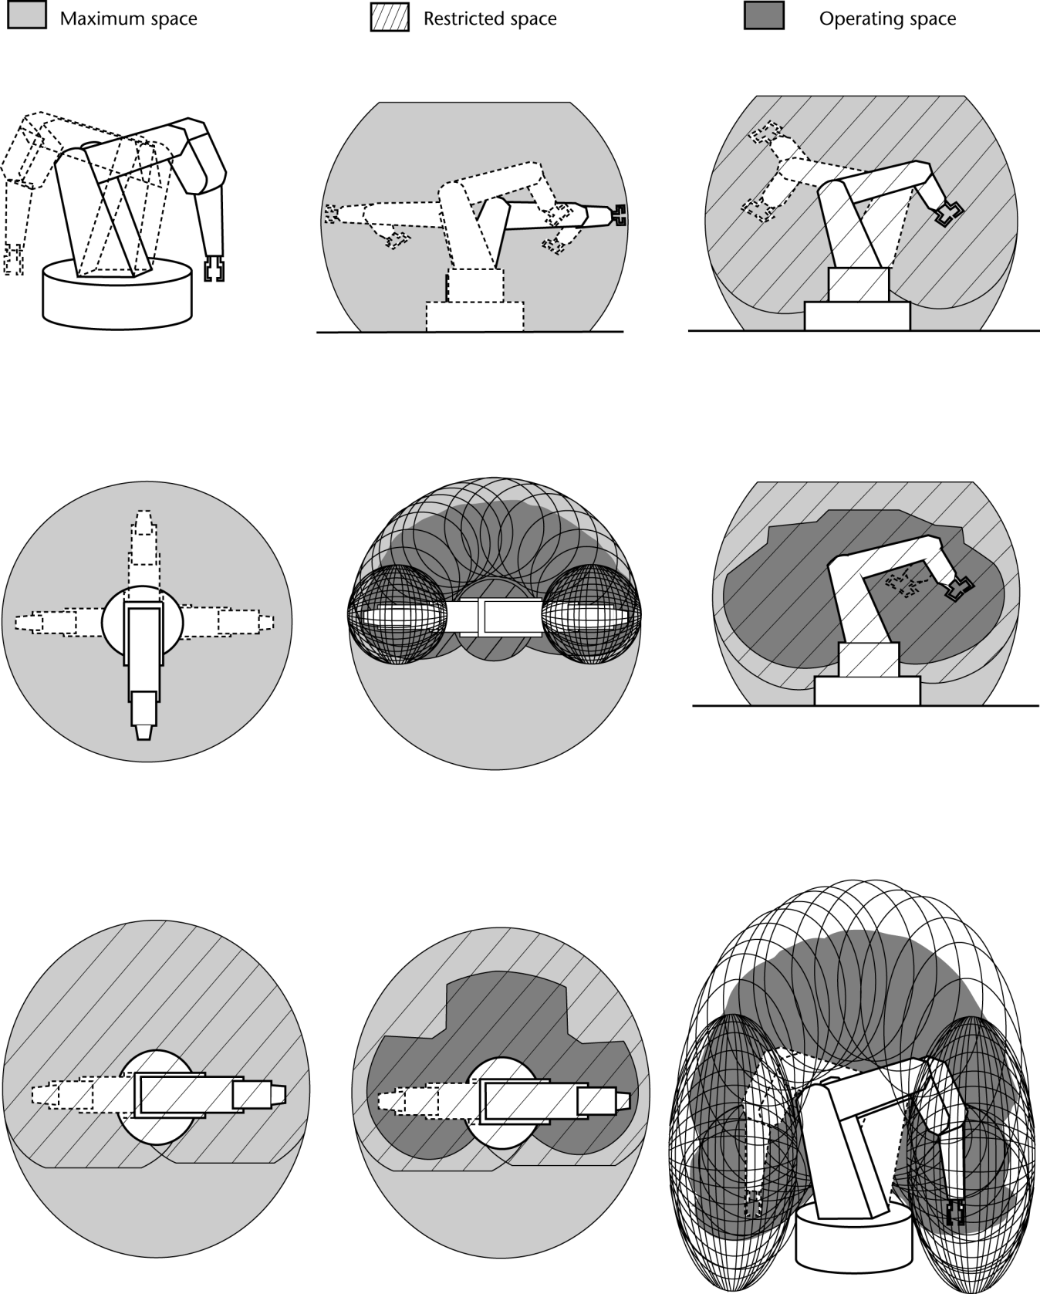
Space (Maximum, Restricted, & Operating) illustrations
CHANGE ILLUSTRATIONS TO INCLUDE AN END-EFFECTOR and PART
Continued
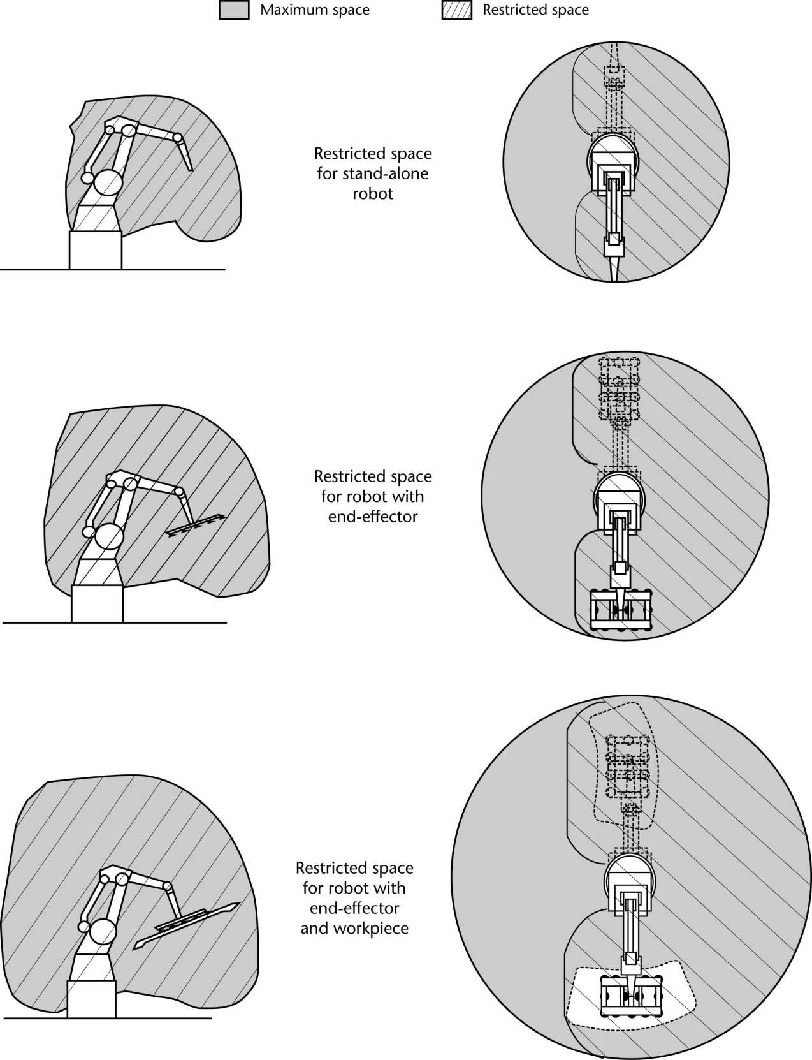
TO BE UPDATED SO ALL ARE SHOWN WITH END-EFFECTOR & PART

A revision and update to the information currently contained in Annex A of the 1999 edition.

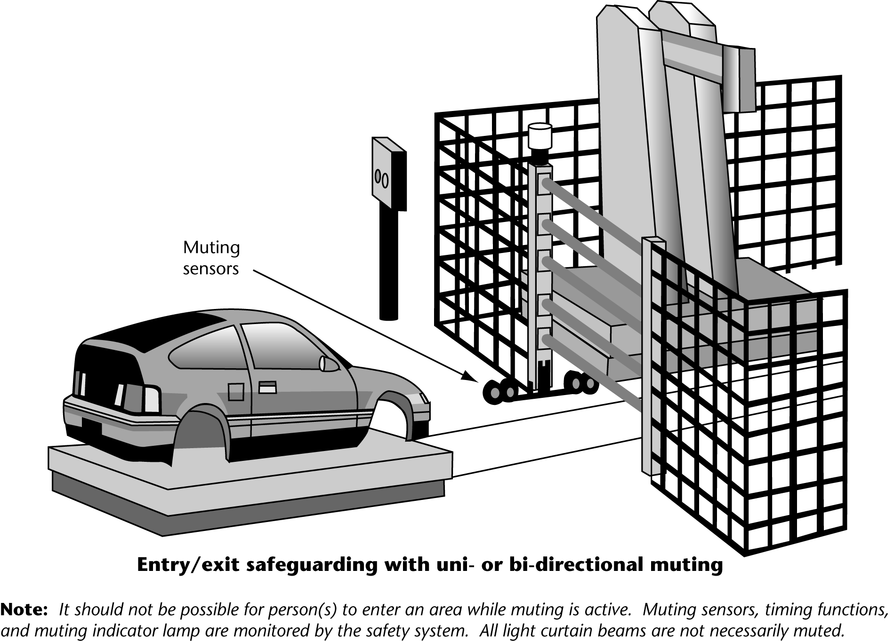
Figure A.3 Typical Work Cell Illustrations

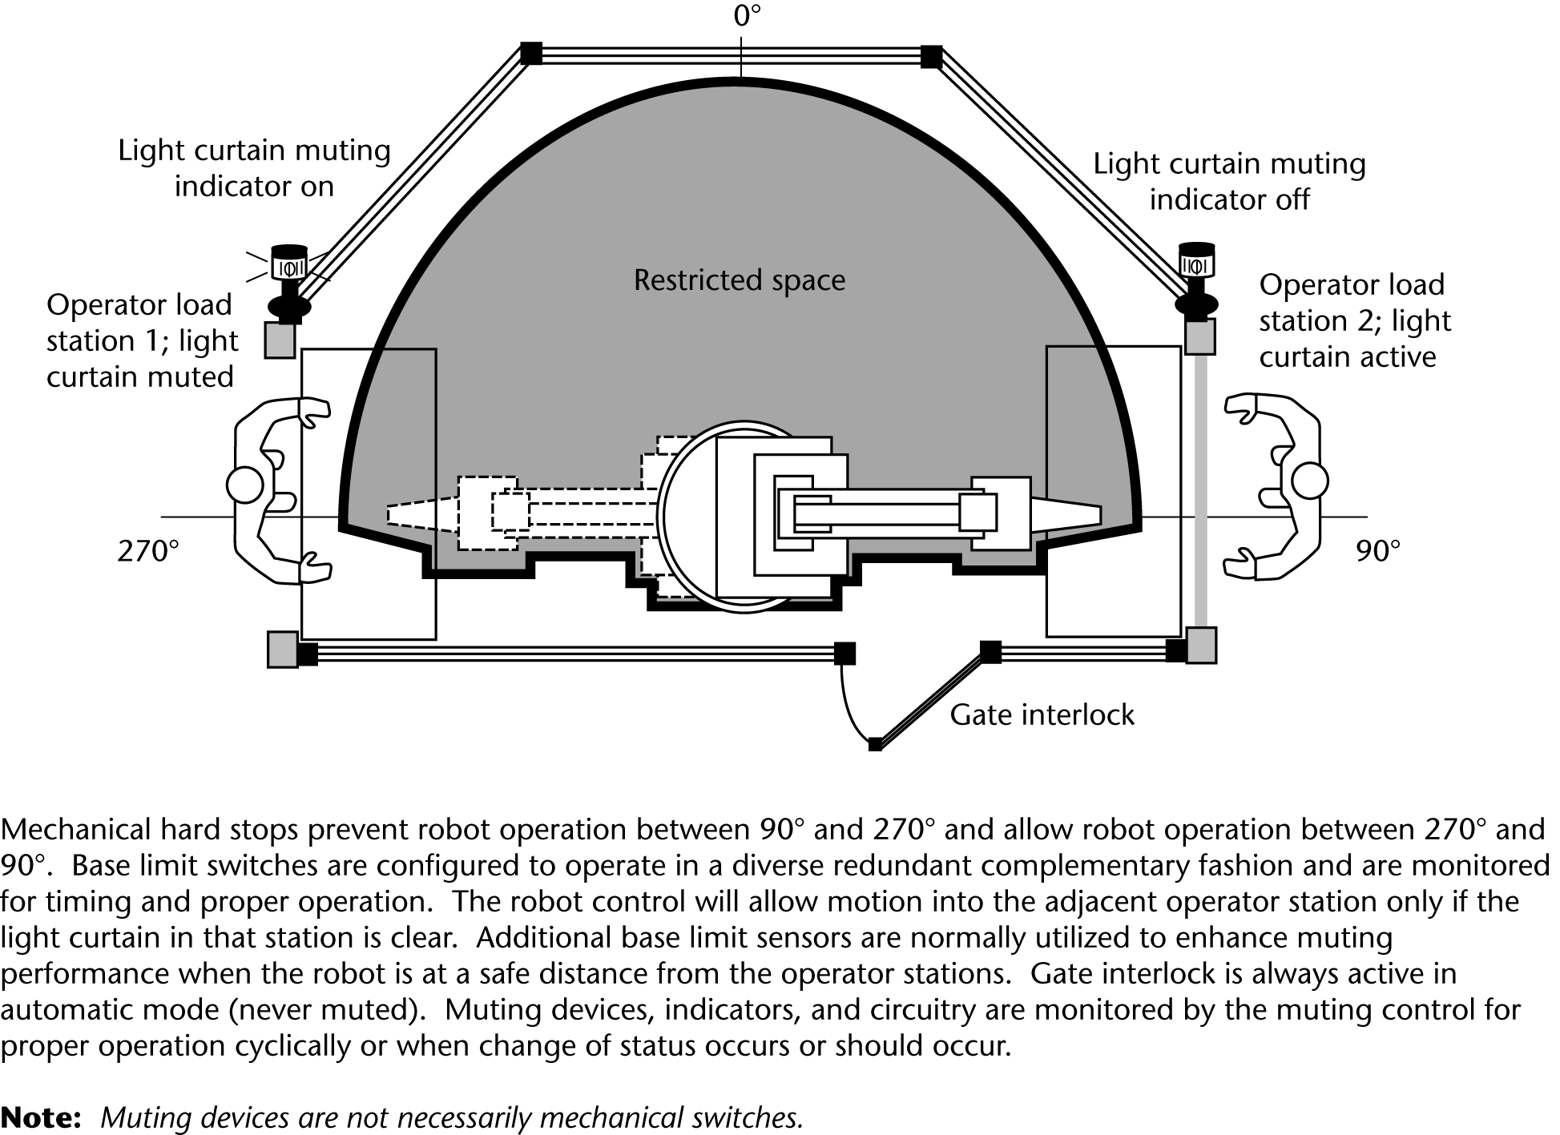

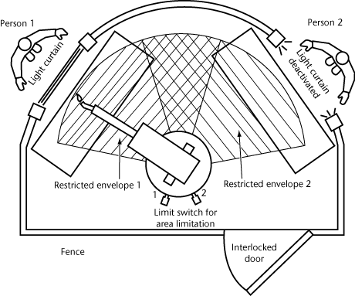
Annex ND
Training

ND.1 Safety training content
Training should include:
- industry standards and instructions designed for the protection of personnel;
- the robot vendor safety recommendations;
- procedures that contain steps related to safety actions;
- lockout and tagout procedures;
- emergency procedures;
- general work place safety procedures
and the following specific training program content based on assigned tasks.
ND.2 Safeguard training
Training on safeguarding devices should include, but not be limited to:
- types of safeguarding devices;
- capabilities/options of safeguarding devices;
- description of devices selected for a specific application;
- function of the selected devices;
- functional test of the device;
- limitations of the selected device.
ND.3 Training the teacher
Training the teacher should include, but not be limited to:
- slow speed control;
- safeguards which are bypassed during teach;
- pendant operation;
- single point of control;
- process safety/control;
- response to abnormal/unexpected events;
- hazards during teach;
1) pinch point locations
2) observation points
3) robot motion at slow versus program speed
4) robot performance in teach
5) singularity
6) slow speed playback;
- auxiliary equipment.
ND.4 Training the operator
Training of the operator should include, but not be limited to:
- robot tasks;
- hazards related to each task;
- response to abnormal/unexpected events;
- recovery of operation;
- auxiliary equipment.
ND.5 Training the operator for process observation
If the capability is provided, training the operator about process observation should include, but not be limited to:
- All items in ND.3 “Training the teacher;”
- hazards involved with:
1) high speed
2) observations points
3) process materials
4) failure modes
5) alternative safeguards
6) path geometry
7) singularity;
- safe path of retreat;
- emergency procedures;
- special operator requirements and procedures for process observation described in Part 2, 5.5.4 and Annex F.
14.2.5 Training maintenance personnel
Training maintenance personnel should include, but not be limited to:
- applicable tasks in ND3 through ND.5 relating to training the teacher and operator;
- hazards involving:
1) preventive maintenance/calibrations
2) troubleshooting
3) repair
4) operational checks
5) singularity
6) failed safety devices
7) failed communication systems
8) process variables
9) process materials;
- emergency operations;
- hazards involved in procedures on live robots versus robots disabled by lockout/tagout;
- hazards involving auxiliary equipment.

Bibliography

[1] (USA) ANSI/ Z10, Occupational Health and Safety Management Systems

