Annex NB-1
Informative
Supplemental Safeguarding Information

- Introduction
The goal of safeguarding is to either prevent access to hazards or control the access, such that a person cannot access a hazard by reaching over, under, around or through a safeguard.

- Span of Control
The span of control of robot system(s) stopping control devices is determined by the physical layout of the robot system and of the integrated manufacturing system, which supports it, as well as the production process itself, and the access necessary for the completion of task. The safety related span of control is verified by a risk assessment. Unless clearly distinguishable, the span of control shall be identified by clear markings and placards.
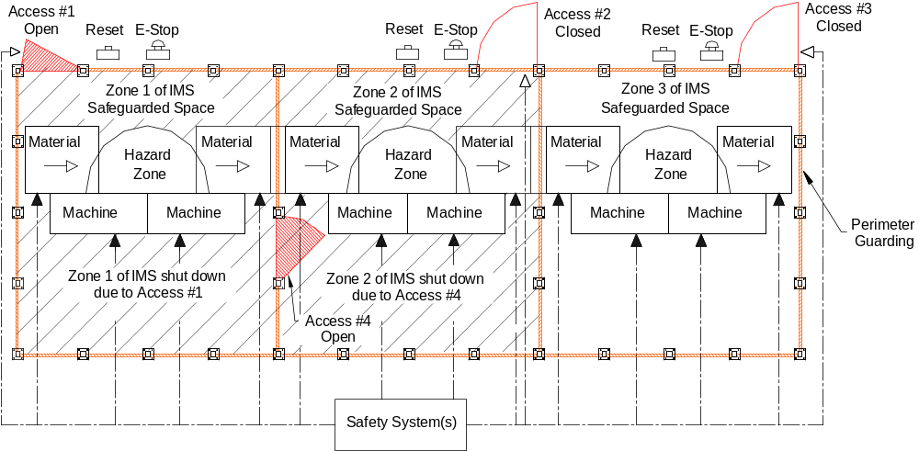

Figure XX (Modification of a figure shown in Annex D of ANSI B11.20-XXXX and ISO 11161)
Figure XX shows a robot system comprised of a safety system controlling three zones. The span of control of each access gate is the zone defined by the perimeter guarding. Opening an access gate initiates a stop command, and prevents restarting of hazardous motion associated with the access gate. Interrupting the internal light curtain - hazardous motion associated with either zone. Both zones will require reset (see Part 2, clause XX). Additional protective measures might be required to address remaining and/or residual hazards.

Annex NB-2
Informative
Supplemental Perimeter Safeguarding Information

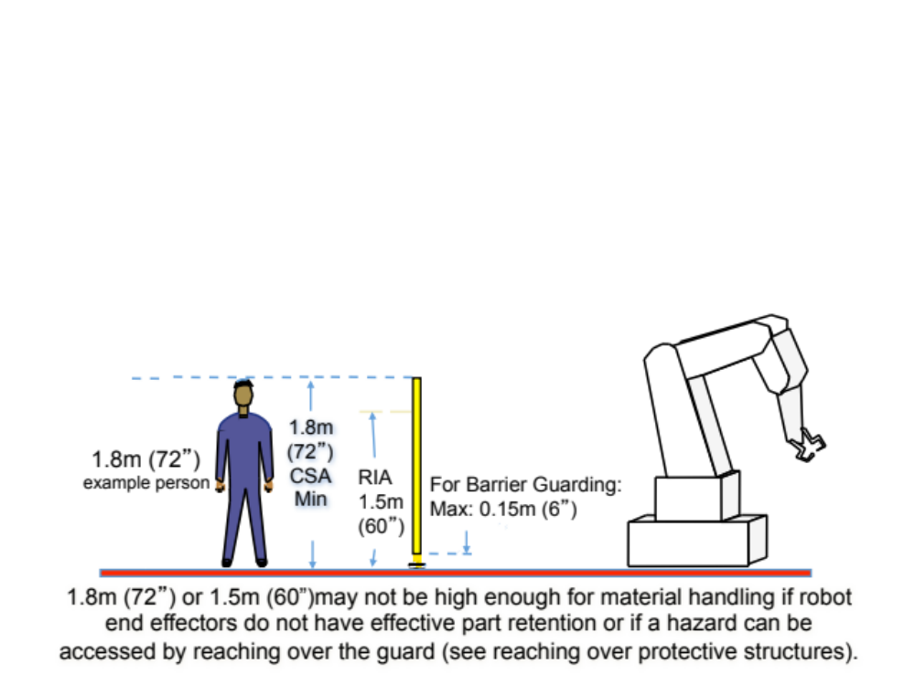
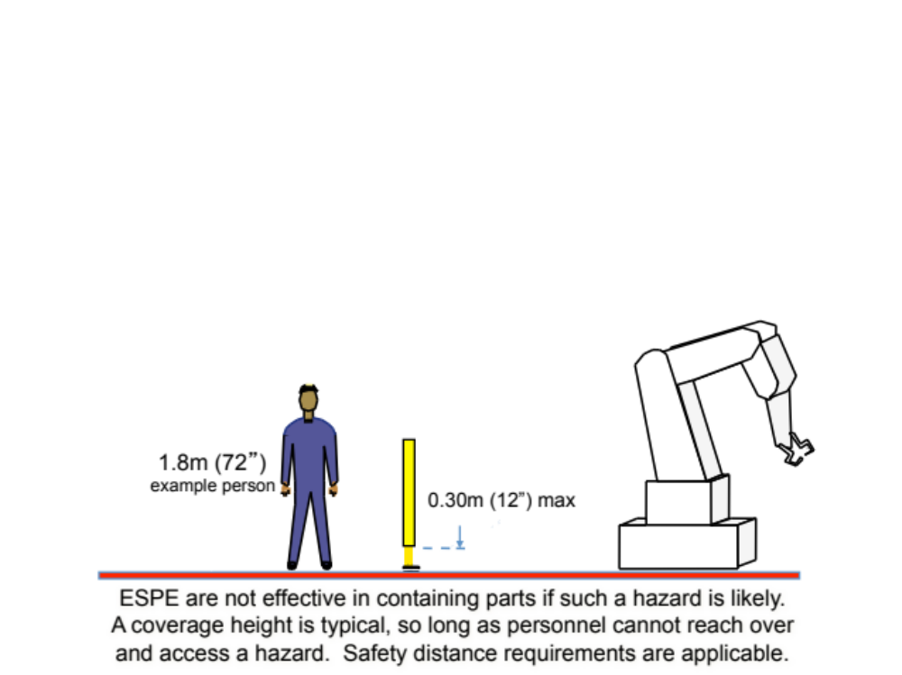

Annex NB-3
Informative
Supplemental Guards (fixed and interlocked) Information

- Positive mode implementation of an interlocked barrier guard
If one electromechanical switch is used to monitor the interlocked guard, positive mode mounting is required. If two electromechanical switches are used to monitor the same interlocked guard, then one is installed in the positive mode and the other should be installed in the negative mode.
See example Electro-mechanical safety switch .
NOTE 1: The use of one or two switches is determined by the risk assessment and compliance with safety performance (reference clause 5.2)
NOTE 2: The one electro-mechanical switch, used for barrier guard interlocking, is a single device with mechanical failure possibilities such that all contacts will agree but be wrong.
INCLUDE language of positive mode mounting
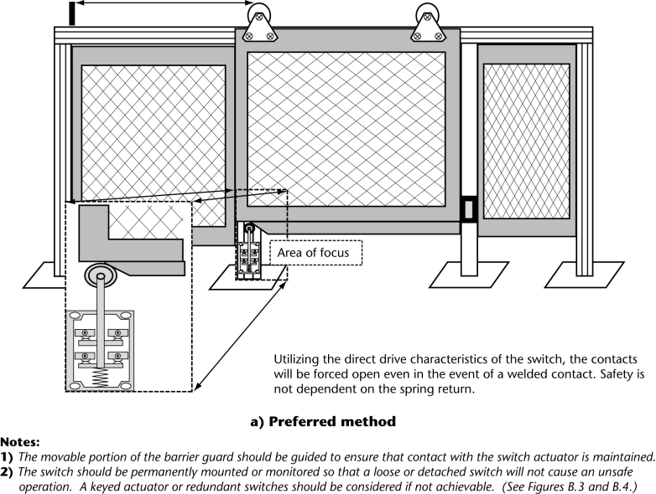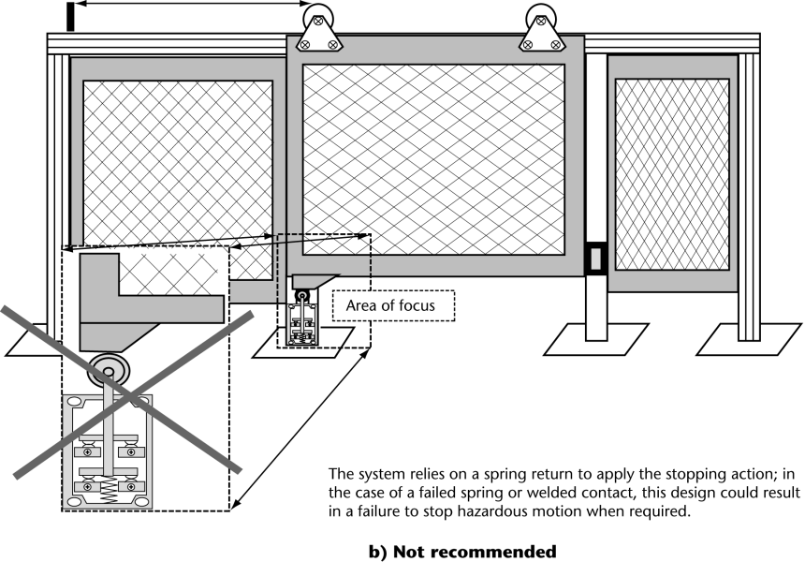

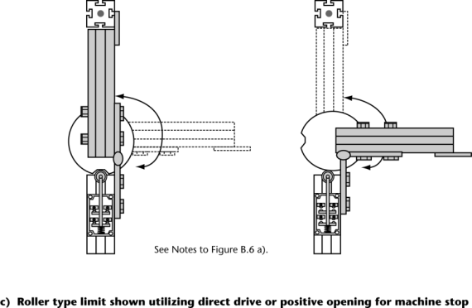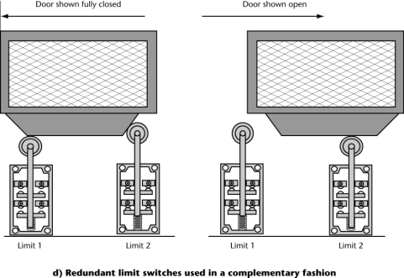

- Examples / means of interlocking a barrier guard
    - Electro-mechanical safety switch
(can be a limit switch or key actuated (key actuated shown))
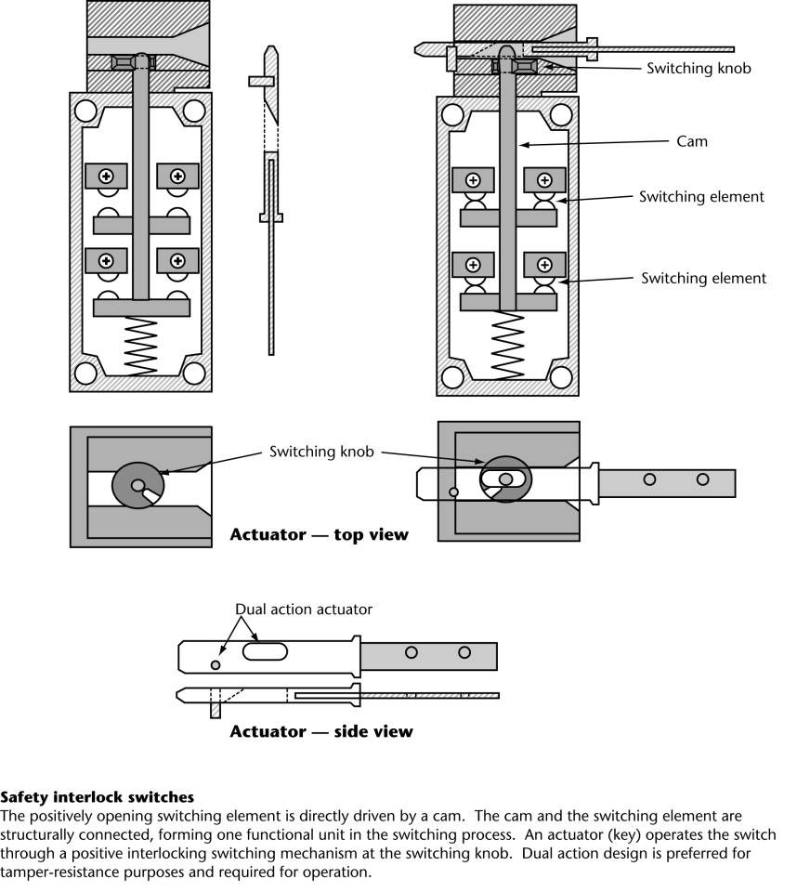
    - Trapped Key
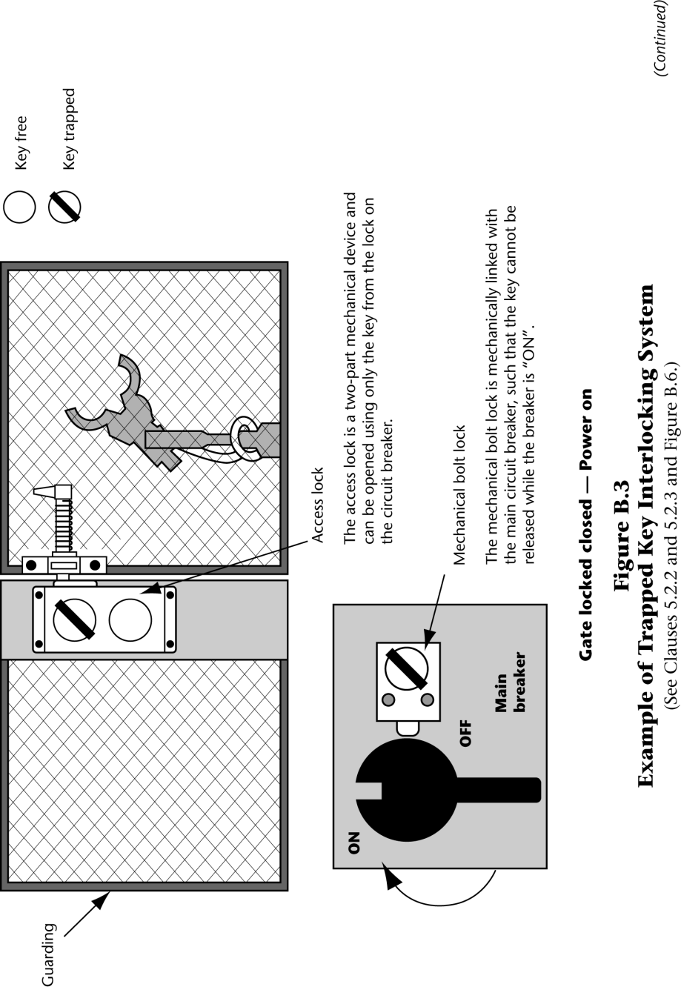
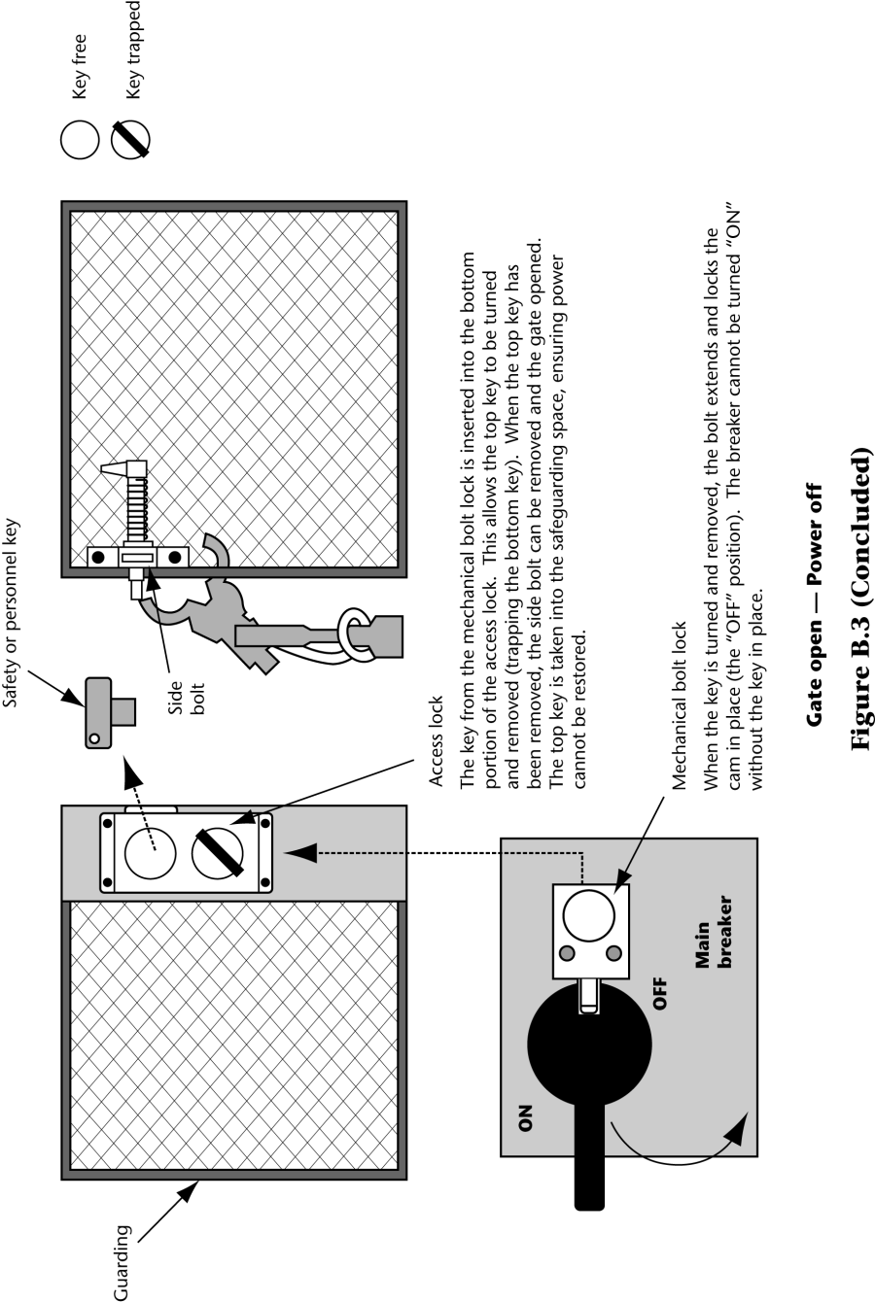
NOTE: Trapped key systems can perform differently and be used for other purposes and functions.

    - Non-contact safety sensor systems (e.g., safety systems using coded magnets, RFID, proximity sensing)

- Emergency egress
Emergency egress might require that the system be capable of being easily unlocked from the inside of the safeguarded space with our without power available, when the possibility of full body access exists. See Clause X.X about requirements for emergency egress.

Annex NB-4
Normative
Minimum (Safe) Distance: Guards / Fixed Distance Guards and Interlocked Guards

See clause X.X for information about guards. See clause 5.10.3.X for interlocked guards.

- Barrier Guard Requirements when reaching OVER a guard or protective structure(s) (to prevent hazard exposure when reaching over the barrier guard)
There are two tables for minimum (safe) distances when reaching OVER the guard or protective structure(s). The Low Risk Table (Table XX) shall be used when the hazards result in a low risk (risk reduction index or risk PL of X or less). The High Risk Table (Table XX) shall be used when the assessed risks are determined to be XX or greater. The applicable table shall be used for fixed distance guards or when the opening in a in a guard (fixed or interlocked) is greater than 120 mm (5 in). Guards shall also comply with clause 5.10.4. If there are multiple hazards for which the guard is used, the worst risk shall be used to determine which table to use (low risk or high risk).
NOTE – (CA and USA) See 5.10.4.2.1 and Annex XX for information about perimeter guards, 5.10.4.3 for interlocked movable guards, and 5.10.4.4 for movable guards with guard locking.

Table X1 – Low risk reaching OVER a guard or protective structures
Where the injury severity is low (index or XX), in accordance with the Annex Risk Assessment, the Low Risk table may be used. When reaching upwards towards the hazard zone, the height (H) to the hazard shall be at least 2500 mm (98 in).
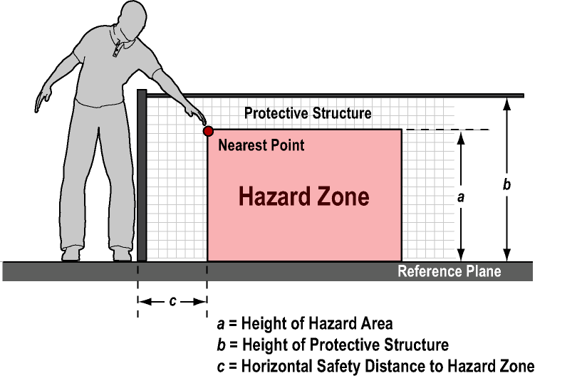
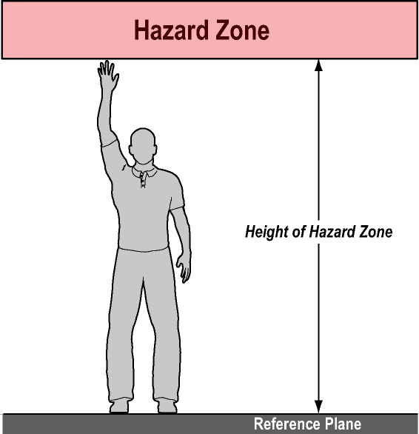
Low Risk:
For hazard zones above 2500 mm (98 in) (reaching upwards),
H shall be at least 2500 mm (98 in)

Height of hazard zone c | Height of Protective Structure b Dimensions in millimeters
Height of hazard zone c | 1,000 (39) | 1,200 (48) | 1,400 (55) |  | 1,600 (63) | 1,800 (72) | 2,000 (80) | 2,200 (87) | 2,400 (94) | 2,500 (98)
a | Horizontal minimum (safety) distance to hazard zone c LOW RISK
And higher  2,500 (98 in) | 0 | 0 |  | 0 | 0 | 0 | 0 | 0 | 0 | 0
2,400 (94) | 100 (4) | 100 (4) |  | 100 (4) | 100 (4) | 100 (4) | 100 (4) | 100 (4) | 100 (4) | 0
2,200 (87) | 600 (24) | 600 (24) |  | 500 (20) | 500 (20) | 400 (16) | 350 (14) | 250 (10) | 0 | 0
2,000 (79) | 1,100 (43) | 900 (36) |  | 700 (28) | 600 (24) | 500 (20) | 350 (14) | 0 | 0 | 0
1,800 (72) | 1,100 (43) | 1,000 (39) |  | 900 (36) | 900 (36) | 600 (24) | 0 | 0 | 0 | 0
1,600 (63) | 1,300 (51) | 1,000 (39) |  | 900 (36) | 900 (36) | 500 (20) | 0 | 0 | 0 | 0
1,400 (55) | 1,300 (51) | 1,000 (39) |  | 900 (36) | 800 (31) | 100 (4) | 0 | 0 | 0 | 0
1,200 (48) | 1,400 (55) | 1,000 (39) |  | 900 (36) | 500 (20) | 0 | 0 | 0 | 0 | 0
1,000 (39) | 1,400 (55) | 1,400 (55) |  | 900 (36) | 300 (12) | 0 | 0 | 0 | 0 | 0
800 (31) | 1,300 (51) | 900 (36) |  | 600 (24) | 0 | 0 | 0 | 0 | 0 | 0
600 (24) | 1,200 (48) | 500 (20) |  | 0 | 0 | 0 | 0 | 0 | 0 | 0
400 (16) | 1,200 (48) | 300 (12) |  | 0 | 0 | 0 | 0 | 0 | 0 | 0
200 (9) | 1,100 (43) | 200 (9) |  | 0 | 0 | 0 | 0 | 0 | 0 | 0
0 | 1,100 (43) | 200 (9) |  | 0 | 0 | 0 | 0 | 0 | 0 | 0

Table X1 Horizontal minimum (safety) distance for
LOW RISK when reaching over a guard or protective structures
NOTE 1 – (CA and US) Do not interpolate numbers. Use the figures that will result in a more conservative outcome. For example, if the height of the hazard is 1300 mm (51 in), then use 1400 mm (55 in). If the protective structure height is 1900 mm (75 in), use 2200 mm (87 in).

Table X2 – High risk reaching OVER a guard or protective structures
Where the injury severity is high (index or XX), in accordance with the Annex Risk Assessment, the Low Risk table may be used. When reaching upwards towards the hazard zone, the height (H) to the hazard shall be at least 2500 mm (98 in).
High Risk:
For hazard zones above 2500 mm (98 in) (reaching upwards), H shall be at least 2700 mm (106 in)

Height of Hazard zone c | Height of Protective Structure b Dimensions in millimeters
Height of Hazard zone c | 1,000 (39) | 1,200 (48) | 1,400 (55) | 1,600 (63) | 1,800 (72) | 2,000 (80) | 2,200 (87) | 2,400 (94) | 2,500 (98) | 2,700 (106)
a | Horizontal minimum (safety) distance to hazard zone c HIGH RISK
2,700 (106 in) | 0 | 0 | 0 | 0 | 0 | 0 | 0 | 0 | 0 | 0
2,600 (102) | 900 | 800 | 700 | 600 | 600 | 500 | 400 | 300 | 100 | 0
2,400 (94) | 1,100 | 1,000 | 900 | 800 | 700 | 600 | 400 | 300 | 100 | 0
2,200 (87) | 1,300 | 1,200 | 1,000 | 900 | 800 | 600 | 400 | 300 | 0 | 0
2,000 (80) | 1,400 | 1,300 | 1,100 | 900 | 800 | 600 | 400 | 0 | 0 | 0
1,800 (72) | 1,500 | 1,400 | 1,100 | 900 | 800 | 600 | 0 | 0 | 0 | 0
1,600 (63) | 1,500 | 1,400 | 1,100 | 900 | 800 | 500 | 0 | 0 | 0 | 0
1,400 (55) | 1,500 | 1,400 | 1,100 | 900 | 800 | 0 | 0 | 0 | 0 | 0
1,200 (48) | 1,500 | 1,400 | 1,100 | 900 | 700 | 0 | 0 | 0 | 0 | 0
1,000 (39) | 1,500 | 1,400 | 1,000 | 800 | 0 | 0 | 0 | 0 | 0 | 0
800 (31) | 1,500 | 1,300 | 900 | 600 | 0 | 0 | 0 | 0 | 0 | 0
600 (24) | 1,400 | 1,300 | 800 | 0 | 0 | 0 | 0 | 0 | 0 | 0
400 (16) | 1,400 | 1,200 | 400 | 0 | 0 | 0 | 0 | 0 | 0 | 0
200 (9) | 1,200 | 900 | 0 | 0 | 0 | 0 | 0 | 0 | 0 | 0
0 | 1,100 | 500 | 0 | 0 | 0 | 0 | 0 | 0 | 0 | 0

Table X2 Horizontal minimum (safety) distance for
HIGH RISK when reaching over a guard or protective structures

- Guard Requirements when reaching UNDER a guard or protective structure(s)
(to prevent hazard exposure when reaching under the barrier guard)
Operators can reach under a guard with their upper limbs or lower limbs. A guard opening, as measured from the adjacent standing surface to the bottom of the guard, greater than 180 mm (7 in) can allow full body access. If the opening is greater than 180 mm (7 in), a square or round opening, the operator can slide past or squeeze under the guard, thereby allowing full body access. In these situations, additional safeguarding shall be provided to either prevent access or to detect access. Protective structures can be used to restrict the free movement of the lower limbs.
See Annex 5.10.4.2.1 and Annex NB-X for requirements of perimeter guards.
NOTE – (CA and USA) See 5.10.4.3 for interlocked movable guard, and 5.10.4.4 for movable guards with guard locking.
The table below shall be used to determine the minimum safe distance from the guard to the nearest hazard, as measured from the guard opening towards the closest hazard.
Opening Under a Guard (fixed or interlocked) e mm (in) | Safety Distance Sr mm (in)
Smallest Dimension | CA and USA
e ≤ 4 ( 0.2) | ≥ 2 ( 0.1)
4 (0.2) [ e ≤ 12 ( 0.5) | ≥ 10 ( 0.4)
12 (0.5) [ e ≤ 20 ( 0.8) | ≥ 120 ( 5 )
20 (0.8) [ e ≤ 80 ( 3 ) | ≥ 850 (33 )
80 (3 ) [ e ≤ 150 ( 6 ) | ≥ 1100 (43 )
Over 150 (6 ) | Not Allowed unless other safeguarding is provided to prevent access or detect access

- Guard Requirements when reaching THROUGH a guard or protective structure(s) (to prevent hazard exposure when reaching through the guard)
  - Reaching through or around a guard by upper limbs:
Anthropomorphic and graphical representations
The requirements for minimum safe distance when reaching through a guard, using an upper limb, are based on anthropometric data of the human arm
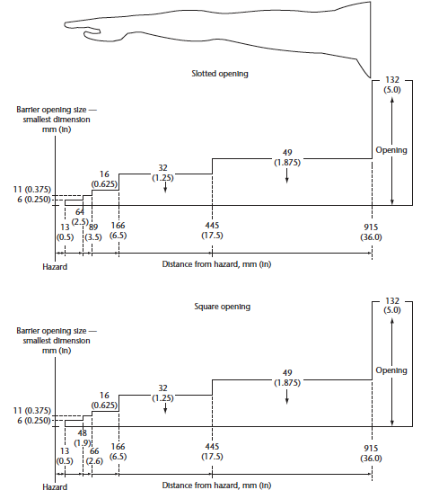

NOTE – (CA & USA) These values do not replace the Dpf values listed in the safety distance formula and examples.

  - Reaching THROUGH a GUARD by Upper Limbs
CA and USA Requirements
Opening e mm (in) |  | Safety Distance Sr mm (in)
Smallest dimension  US: OSHA O-10 (max opening) |  | Slotted  US: OSHA O-10  Min Distance | Square or Round  US: OSHA O-10  Min Distance
e ≤ 4 (0.16) | ≥ 13 (0.5) |  | ≥ 13 (0.5)
4 (0.16) < e ≤ 6 (0.24)  US: OSHA O-10 | ≥ 13 (0.5)  ≥ 32 (1.5) |  | ≥ 5 (0.2)  ≥ 32 (1.5)
6 (0.24) < e ≤ 8 (0.31) | ≥ 64 (2.5) |  | ≥ 48 (1.9)
8 (0.31) < e ≤ 10 (0.39) | ≥ 64 (2.5) |  | ≥ 48 (1.9)
10 (0.39) < e ≤ 11 (0.43) | ≥ 64 (2.5) |  | ≥ 48 (1.9)
11 (0.43) < e ≤ 12 (0.47) | ≤ 89 (3.5) |  | ≤ 66 (2.6)
12 (0.47) < e ≤ 16 (0.63) | ≥ 89 (3.5) |  | ≥ 66 (2.6)
16 (0.63) < e ≤ 20 (0.79) | ≥ 166 (6.5) |  | ≥ 166 (6.5)
20 (0.79) < e ≤ 30 (1.18) | ≥ 166 (6.5) |  | ≥ 166 (6.5)
30 (1.18) < e ≤ 32 (1.26) | ≥ 166 (6.5) |  | ≥ 166 (6.5)
32 (1.26) < e ≤ 40 (1.57) | 445 (17.5) |  | 445 (17.5)
40 (1.57) < e ≤ 49 (1.93) | 445 (17.5) |  | 445 (17.5)
49 (1.93) < e ≤ 130 (5) | 915 (36) |  | 915 (36)
180 (7) < e | Additional safeguarding required to prevent or detect entry
240 ( X) < e | Whole body possible. Additional safeguarding required to prevent or detect entry
Over 240 | Not allowed  unless other safeguarding is provided to prevent access or detect access
NOTE 1 – (CA & USA) The dimension of the opening, e, corresponds to the side of a square opening, the diameter of a round opening and the narrowest dimension of a slot opening
NOTE 2 – (CA & USA) These Safe Distance values do not replace the Dpf values listed in the safety distance formula and examples.
NOTE 3 – (CA & USA) per ISO 13857, 850 mm (33 in) is considered the standard arm reach.

ISO 13857 Requirements for Reference Purposes
Part of Arm | Graphic | Opening e mm (in) | Safety Distance Sr mm (in)
Part of Arm | Graphic | Smallest dimension | Slotted | Square | Round
Finger tip | 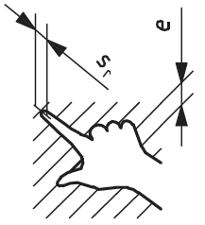 | e ≤ 4 (0.16) | ≥ 2 (0.08) | ≥ 2 (0.08) | ≥ 2 (0.08)
Finger tip |  | 4 (0.16) < e ≤ 6 (0.24) | ≥ 10 (0.39) | ≥ 5 (0.2) | ≥ 5 (0.2)
Finger tip |  | 6 (0.24) < e ≤ 8 (0.31) | ≥ 20 (0.79) | ≥ 15 (0.59) | ≥ 5 (0.2)
Finger to knuckle joint | 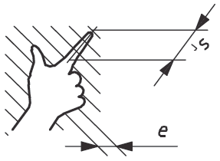 | 6 (0.24) < e ≤ 8 (0.31) | ≥ 20 (0.79) | ≥ 15 (0.59) | ≥ 5 (0.2)
Finger to knuckle joint |  | 8 (0.31) < e ≤ 10 (0.39) | ≥ 80 (3.15) | ≥ 25 (0.98) | ≥ 20 (0.79)
Hand | 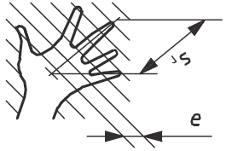 | 10 (0.39) < e ≤ 12 (0.47) | ≥ 100 (3.94) | ≥ 80 (3.15) | ≥ 80 (3.15)
Hand |  | 12 (0.47) < e ≤ 20 (0.79) | ≥ 120 (4.72) | ≥ 120 (4.72) | ≥ 120 (4.72)
Hand |  | 20 (0.79) < e ≤ 30 (1.18) | ≥ 850 (33) | ≥ 120 (4.72) | ≥ 120 (4.72)
Arm up to junction with shoulder | 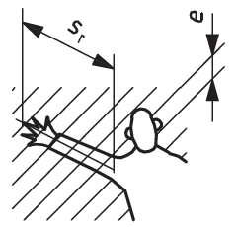 | 20 (0.79) [ e ≤ 30 (1.18) | ≥ 850 (33) | ≥ 120 (4.72) | ≥ 120 (4.72)
Arm up to junction with shoulder |  | 30 (1.18) [ e ≤ 40 (1.57) | ≥ 850 (33) | ≥ 200 (7.87) | ≥ 120 (4.72)
Arm up to junction with shoulder |  | 40 (1.57) [ e ≤ 120 (4.72) | ≥ 850 (33) | ≥ 850 (33) | ≥ 850 (33)
Over |  | 120 (4.72) < e | See Annex NE3 Reaching Over
NOTE 1 – The dimension of the opening, e, corresponds to the side of a square opening, the diameter of a round opening and the narrowest dimension of a slot opening
NOTE 2 – These Minimum (Safe) Distance values do not replace the Dpf values listed in the safety distance formula and examples.
NOTE 3 – (CA & USA) per ISO 13857, 850 mm (33 in) is considered the standard arm mm.reach, while ANSI and CSA consider the arm reach to be 915 mm (36 in).
  - Reaching THROUGH a GUARD by Upper Limbs – Irregular openings
For irregular openings, the following steps shall be performed to determine the minimum safe distance:
a) Determine the guard openings that correspond to round, square, and slotted openings.
- the diameter of the smallest round opening. (dimension 3 as shown below),
- the side of the smallest square opening. (dimension 2, as shown below), and
- the width of the narrowest slot opening, (dimension 1, as shown below), into which the irregular opening can be completely inserted [see hatched area in the Figures below]
b) With these round, square, and slot opening dimensions, determine the corresponding safety distance using the table below. The safe distance shall not exceed the largest of the safety distances that resulting from the guard openings (round, square, slot). The smallest safety distance resulting from the three guard openings (round, square, slot) may be used.
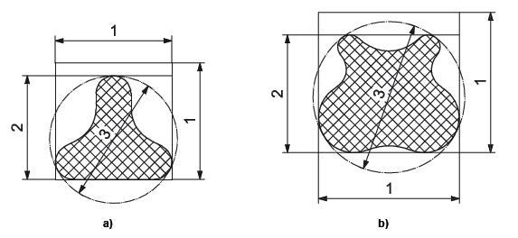

Opening e mm (in) | Safety Distance Sr mm (in)
Per Instructions Above | Dimension 1: Round | Dimension 2: Square | Dimension 3: Slotted
e ≤ 4 (0.16) | ≥ 2 (0.1) | ≥ 2 (0.1) | ≥ 2 (0.1)
4 (0.16) < e ≤ 6 (0.24) | ≥ 5 (0.2) | ≥ 5 (0.2) | ≥ 10 (0.4)
6 (0.24) < e ≤ 8 (0.31) | ≥ 5 (0.2) | ≥ 15 (0.6) | ≥ 20 (0.8)
8 (0.31) < e ≤ 10 (0.39) | ≥ 20 (0.8) | ≥ 25 (1) | ≥ 80 (3)
10 (0.39) < e ≤ 12 (0.47) | ≥ 80 (3) | ≥ 80 (3) | ≥ 100 (4)
12 (0.47) < e ≤ 20 (0.79) | ≥ 120 (5) | ≥ 120 (5) | ≥ 120 (5)
20 (0.79) < e ≤ 30 (1.18) | ≥ 120 (5) | ≥ 120 (5) | ≥ 915 (36)
30 (1.18) < e ≤ 40 (1.57) | ≥ 120 (5) | ≥ 200 (8) | ≥ 915 (36)
40 (1.57) < e ≤ 120 (4.72) | ≥ 915 (36) | ≥ 915 (36) | ≥ 915 (36)
120 (4.72) < e | See Annex NB-X Reaching Over

  - Reaching THROUGH a GUARD or Protective Structure – with limitation of movement

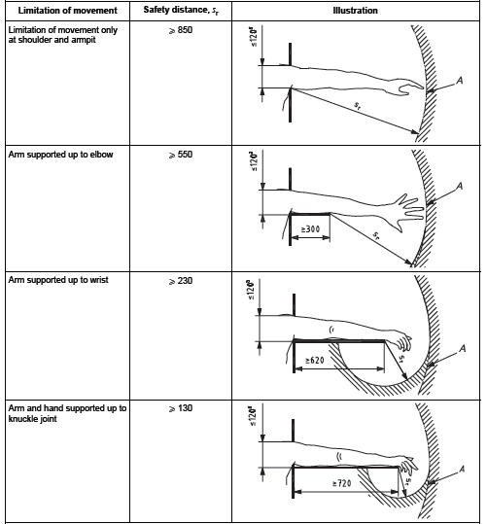
A = range of movement of the arm.
Sr – radial safety distance.
a = the diameter of a round opening, side of square opening, or width of a slotted opening.

NOTE: Per ISO 13857, 850 mm (33 in) is considered the standard arm reach, while ANSI and CSA consider the arm reach to be 915 mm (36 in)

  - Reaching THROUGH a GUARD or Protective Structure – with additional protective structures
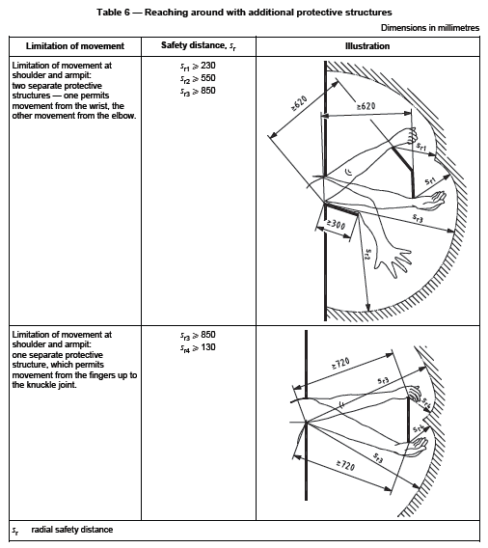

NOTE: Per ISO 13857, 850 mm (33 in) is considered the standard arm reach, while ANSI and CSA consider the arm reach to be 915 mm (36 in).

  - Reaching THROUGH a GUARD by Lower Limbs

Part of lower limb | Graphic | Opening e mm (in) | Safety Distance Sr mm (in)
Part of lower limb | Graphic | Smallest dimension | Slotted | Square or Round
Toe tip | 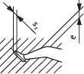 | e ≤ 5 (0.2 ) | 0 (0) | 0 (0)
Toe tip |  | 5 (0.2)< e ≤ 15 (0.6) | ≥ 10 (0.4) | 0 (0)
Toe |  | 15 (0.6)< e ≤ 35 (1.4) | ≥ 80 (3.2) | ≥ 25 (1.0)
Foot | 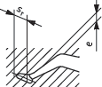 | 35 (1.4) < e ≤ 60 (2.4) | ≥ 180 (7.1) | ≥ 80 (3.1)
Foot |  | 60 (2.4) < e ≤ 80 (3.1) | ≥ 650 (26) | ≥ 180 (7.1)
Leg:  Toe tip to knee | 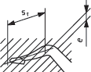 | 80 (3.2) < e ≤ 95 (3.7) | ≥ 1100 (43) | ≥ 650 (26)
Leg:  Toe tip to crotch | 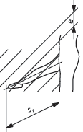 | 95 (3.7) < e ≤ 180 (7.1) | ≥ 1100 (43) | ≥ 1100 (43)
Leg:  Toe tip to crotch |  | 180 (7.1) < e ≤ 240 (9.5) | Not allowed unless other safeguarding is provided to prevent access or detect access | ≥ 1100 (43)

Annex NB-5
Informative
Sensitive Protective Devices
There are numerous measures and safeguarding devices which can be used to detect the presence of an individual at a predetermined location where that location provides access to a hazard. Sensitive Protective Equipment (SPE) relies on certain physical properties of their design to detect an individual’s presence without a specific conscious act on their part to trigger the protective measure. To assure that these devices provide appropriate protection, certain conditions in their application is required. These constraints are determined through a combination of the physical properties of the device and the anthropometric attributes.
- AOPD (Active Opto-electronic Protective Device)
Resolution / Minimum Object Sensitivity
AOPD (light curtains and safety beams) provide an active protection plane through the projection of individually spaced beams of light. When the beams are interrupted, and no longer received by the receiver, the safety outputs are forced to the off state.
Minimum object sensitivity / resolution (Os), is the smallest object which will always be detected, regardless of the emitter to receiver separation distance, making it unaffected by optical gain. Typically, this is the beam-to-beam centerline dimension plus the beam diameter. This results with at least one beam being obstructed at any time.
NOTE: See exception known as Floating Blanking below.
Light Curtain/ Safety Beam Resolution (or Minimum Object Sensitivity)
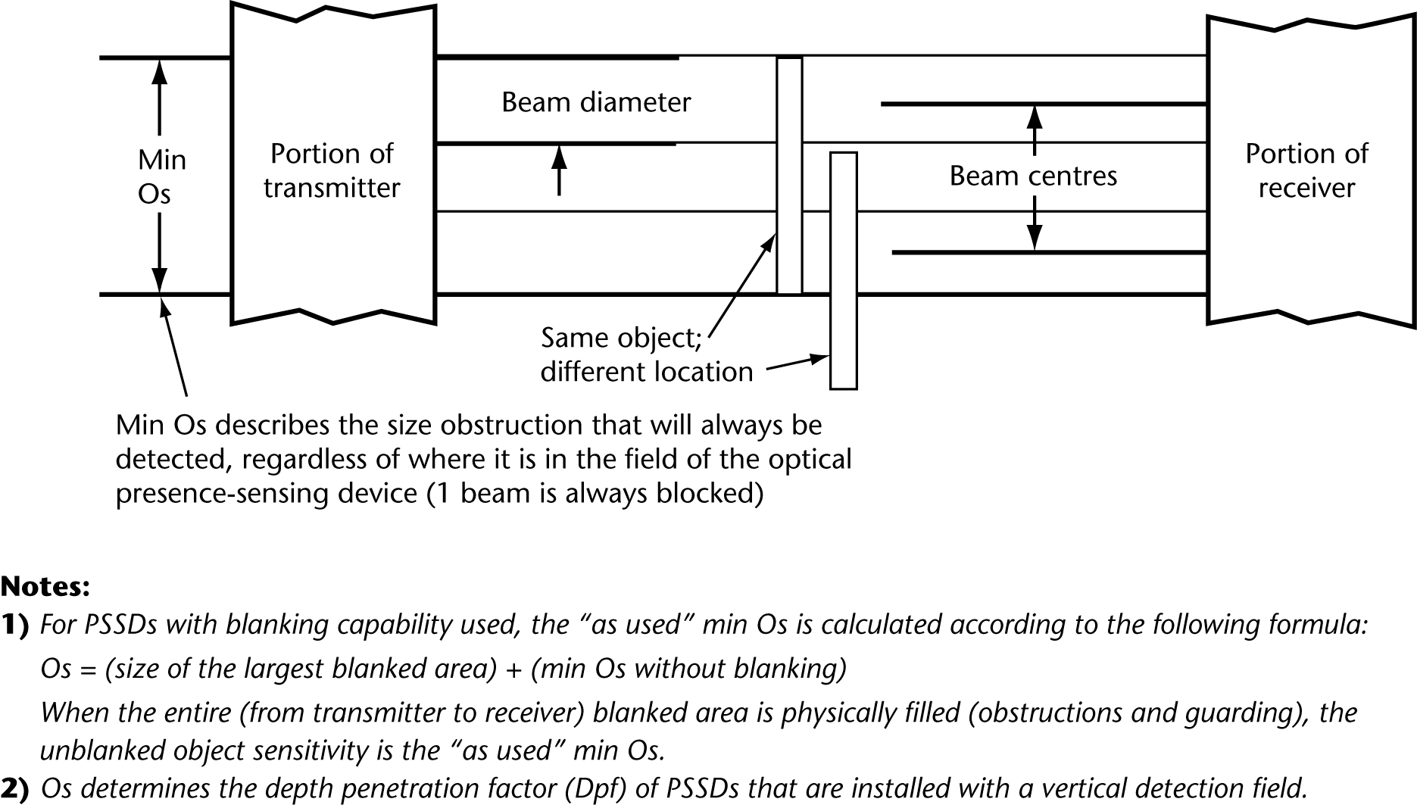
AOPD Blanking
There are two types of blanking: fixed blanking and floating blanking.
Fixed Blanking is used when an object such as fixed tooling is in the detection field. Depending on product specifications, this can be configurable in both the number of beams and their location(s) (e.g., contiguous or not). An increase in the beams blocked is interpreted as a normal intrusion of the protective filed and produces a protective stop.
NOTE: Fixed blanking results in an opening in the protective field. This opening needs be either guarded over the entire span by other protective means (typically physical guarding) or the minimum (safe) distance needs to be increased to correspond to the resolution with the opening.
Floating Blanking, sometimes called Reduced Resolution, permits the blocking of one or more adjacent beams, often in multiple sets, within the detection field. This allows objects to pass through the detection field without producing a protective stop even though one or more beams are obstructed by an intrusion.
NOTE: this feature increases the Minimum Object Size (Resolution) and the Minimum (safety) Distance must be adjusted accordingly
AOPD Reflectivity
Installations need to be tested to ensure that the installation does not create any optical short circuits.
To reduce the potential of an optical short circuit, which utilizes a reflective surface behind the detection field, and alters the field’s location Type 4 safety light curtains may not have a beam divergence of more than 2.5 degrees from their optical centre.

- Safety Laser Scanners
Scanners detect an object in their field of view. The scanner sends a series of pulses of light at radial intervals along an arc (typically 180 degrees or more) and determines the “time of flight” until the reflected beam is detected. With the angular position and the time of fight of the pulse, the scanner can locate the origin of the reflection. A software program facilitates the definition of pairs of fields to be monitored by the beams. Typically these are Warning and Protection Fields.
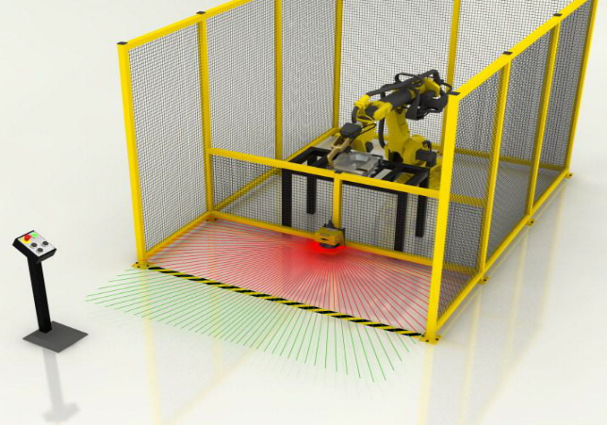

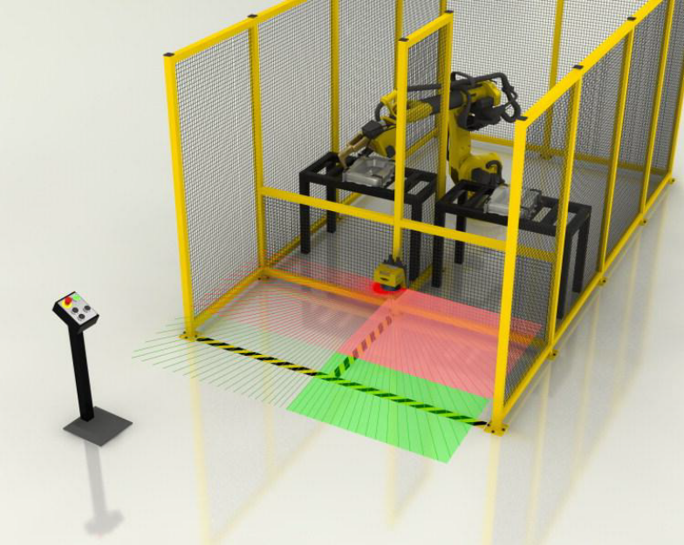
Safeguarding Fields
Warning Fields
Scanner Resolution (Minimum Object Sensitivity)
The angular position and distance to an object’s reflection is compared to the defined protection field, and if found within that field, produces a protective stop. Since the field of view is a series of radial lines, even small objects which are close to the center of the sensor, may produce a large “non-detect” shadow zone behind the object. The size will depend on both the distance of the object from the scanner, and the depth of the protective field and thus extension of the shadow beyond the object.
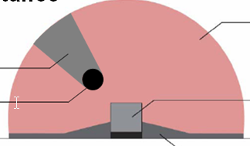
Scanner
Detection Zone
Small Object
Increasingly larger “non-detect” zone
Depending on product, it can be possible to select resolution/ minimum object sensitivity (from 30mm to 70mm), typically with an accompanying reduction of depth of field detection.

Scanner Reflectivity
Installations need to be tested to ensure that the installation does not create any optical short circuits.
Scanners by their design are very sensitive to their specific light source wavelength, and tend to reject light from other sources. It is possible to saturate the scanner optical sensor circuit and cause an error shutdown condition. Due to their extreme sensitivity, they should not be used where they will be within line of sight of shiny objects, as this may affect their ability to accurately resolve the location of other targets.

- Pressure sensitive detective equipment (PSDE)
Safety Mat Systems
The Pressure Sensitive Safety mat is typically constructed of two conductive surfaces separated by a series of non-conductive elastomeric supports. There are other technologies and construction techniques, such as multiple switches and fiber-optic fabric, however they all rely on the weight of the operator to deflect the mat surface, thereby detected their presence on the mat surface.
Safety Mat Sensitivity
By design, mats intended for use by individuals who weigh more than 35kg (77.2 lb) must be capable of detecting a round test object 80mm (3.15in) in diameter, applying a force of 300 Newtons (67.44 lb) parallel to the mat surface. A safety mat control system is needed for a safety mat to be properly integrated.
Multiple mat systems: Due to the construction of some mats,, some safety mats have a perimeter which is inactive. When two or more of these sorts of safety mats are used to create a larger sensing surface, the mating edges need to maintain a uniform sensitivity. This is typically achieved by a special joining hardware which transfers force from the insensitive joint to the mat(s) active area.
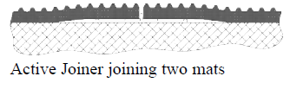
Active Joiner assures that the mat will trip if an individual walks along the multiple mat joint
Due to the single point of failure of the conducting mat surfaces and the inability to functionally test the mat system (simulate the mat deflection and thereby detecting a person), these devices can presently achieve a Cat 3 safety level performance PLd.

Safety Edge (Pressure Sensitive Edge)
Safety Edges are resilient structures, typically tubular in construction, which detect when the structure is compressed. Methods of detection may be contact sensing, blocking of an optical beam, or increase in internal pressure. A controller is typically used to detect the change of state and signal the safeguarding function. The design parameter of great importance for such applications as powered or automatic rolling doors, is the edges’ over-travel. This is the amount of deformation (travel) the Safety Edge can sustain from the end of pre-travel (point of operation) until the assembly becomes a rigid member. The stopping capability of the door needs to assure that all motion ceases before the Safety Edge is compressed into a solid member, and thus itself becomes the hazardous surface. This is accomplished by design of the assembly in terms of the amount of travel from the point of operation until the assembly is rigid. Often this is accomplished by a collapsible support, which is an integral part of the edge mounting surface.
Safety Edge Sensitivity
The test standard requires that the edge detect a normal force of 150N (33.7 lb.) for Minimum (safety) Distance (including cut-off for angled applications).

Annex NB-6
Normative
Protective Devices Minimum (safety) Distance

The minimum (safety) distance is determined by a combination of factors: opening size, shape of opening, and height/width of coverage (reach over/ reach under/ reach around/ reach through). The implementation needs to be based on the location and positioning of the operator. For perimeter safeguarding, see 5.10.2, 5.10.2.1, 5.10.4.3. For barrier guards, see clause 5.10.3.1 and 5.10.3.2. For interlocked barrier guards, see clause 5.10.3.1, 5.10.3.2, and 5.10.3.3.
Minimum (Safe) Distance Formula
Minimum (Safety) Distance Formula | ANSI RIA R15.06  CSA Z434 | For Reference  From ISO 13855
Where | Ds = [K x (Ts + Tr)] + Dpf | S = (K x T) + C
- Minimum (safe) distance,  in millimeters (mm) | Ds | S
- Speed constant, a parameter, derived from data on approach speeds of the body or parts of the body, in millimeters per second (mm/s), | K  ≥ 1600 mm/sec | K  ≥ 1600 or 2000 mm/sec
- Overall system stopping performance,  in seconds (s) | (Ts + Tr) | T
- Worst anticipated stopping time of the robot and the control system (other machines use the worse stopping time of the machine/equipment and the control system), in milliseconds | Ts | Included in T
- Response time of the protective device, including its interface, in milliseconds | Tr | Included in T
- Depth Penetration Factor = intrusion distance,  in millimeters (mm) | Dpf | C  Where C = 8.0 x [Os – (14 mm/ 0.6 in)] but not less than 0 mm (0 in)
NOTE 1 – (CA/USA) A greater value can be required for K in specific applications and when body motion needs to be considered.
NOTE 2 – (CA/USA) ISO 13855 requires that the minimum safe distance is first calculated using a K of 2000 mm/sec. If the resulting minimum safe distance is greater than 500 mm, then a K of 1600 mm/sec can be used to determine the minimum safe distance.
NOTE 3 – [CA/US] When reaching through the detection field of an AOPD that has a resolution/ minimum object sensitivity, the formula to calculate the Dpf is 3.4 x (Os - …
NOTE 4 – Dpf / C will change depending on the type of device and the application. See Annex X - Figure X for specific values. The Dpf / C can consist of two parts – see X.X (next section). The formulas are different.

INTERLOCKED BARRIER GUARDS
When using interlocked barriers, Dpf / C can apply. Dpf / C is be the distance that an operator could extend toward the hazard while opening the interlocked barrier. This is possible by reaching over, under, around, or through the barrier or barrier frame. Clause 5/10.x and Annex X shall be used to determine the Dpf / C.
If there is a consistent, measurable delay in actuating a stop when using interlocked barriers and an operator cannot access the hazard before a stop is initiated, then the Tr (response time) may be reduced by the measured delay, however Tr shall not be less than zero.
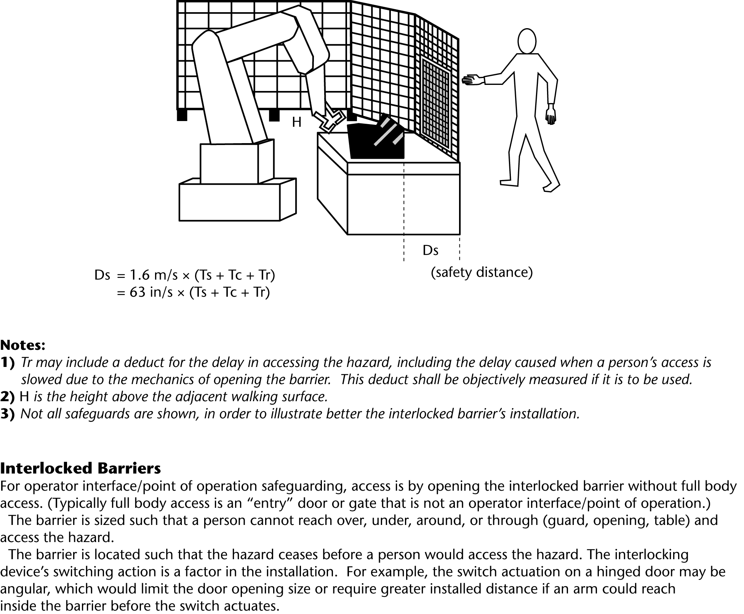
4) To insure maximum and consistent Tc(?), the door should be hinged to swing out

TWO-HAND CONTROLS:
When two-hand controls are used for safeguarding purposes, the minimum safe distance shall comply with Annex NB-XX and Figure ?. A Dpf/ C of 250 mm shall be used, unless there is a means to prevent the hands or other body parts from encroaching towards the hazard zone (e.g., shrouding the two-hand controls, orientation of the work station).
Guards on both sides and rear
Operator
Two Hand Control
Field of visual acuity
Hazard

The operator of the two hand control shall be positioned facing the hazard. The operator shall have full visual acuity and control of individuals approaching the unguarded part of the hazard. All other areas shall be provided with other safeguarding measures.

ESPE – angled detection field
When ESPEs have a vertical plane of intrusion/detection or an angled plane that is less than 30 degrees, the minimum safe distance shall comply with vertical plane installations. See Figure ? (next figure).
When ESPEs have an angled plane of intrusion/detection that is greater than 30 degrees, the minimum safe distance shall comply with horizontal plan installations and Figure ? (next figure).
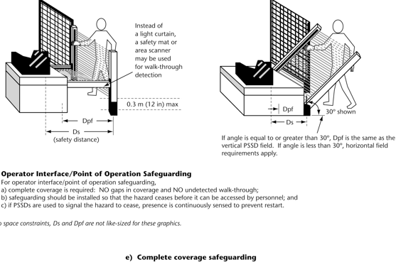

ESPE – vertical detection field
Install the ESPE such that both reach through and reach over dimensions are determined, and the ESPE is installed no closer than the largest dimension (reach through or reach over).
Reach through (Dpf)
Depth Penetration Factor (Dpf) is the distance that an individual can get closer to the hazard(s) without being detected by the ESPE.
Dpf when reaching through the
vertical detection field of the ESPE (light curtains and safety beams)
Dpf / C = 3.4 x (Os – 6.875 mm) = 3.4 x (Os – 2.750 in) but not less than 0 mm (0 in)
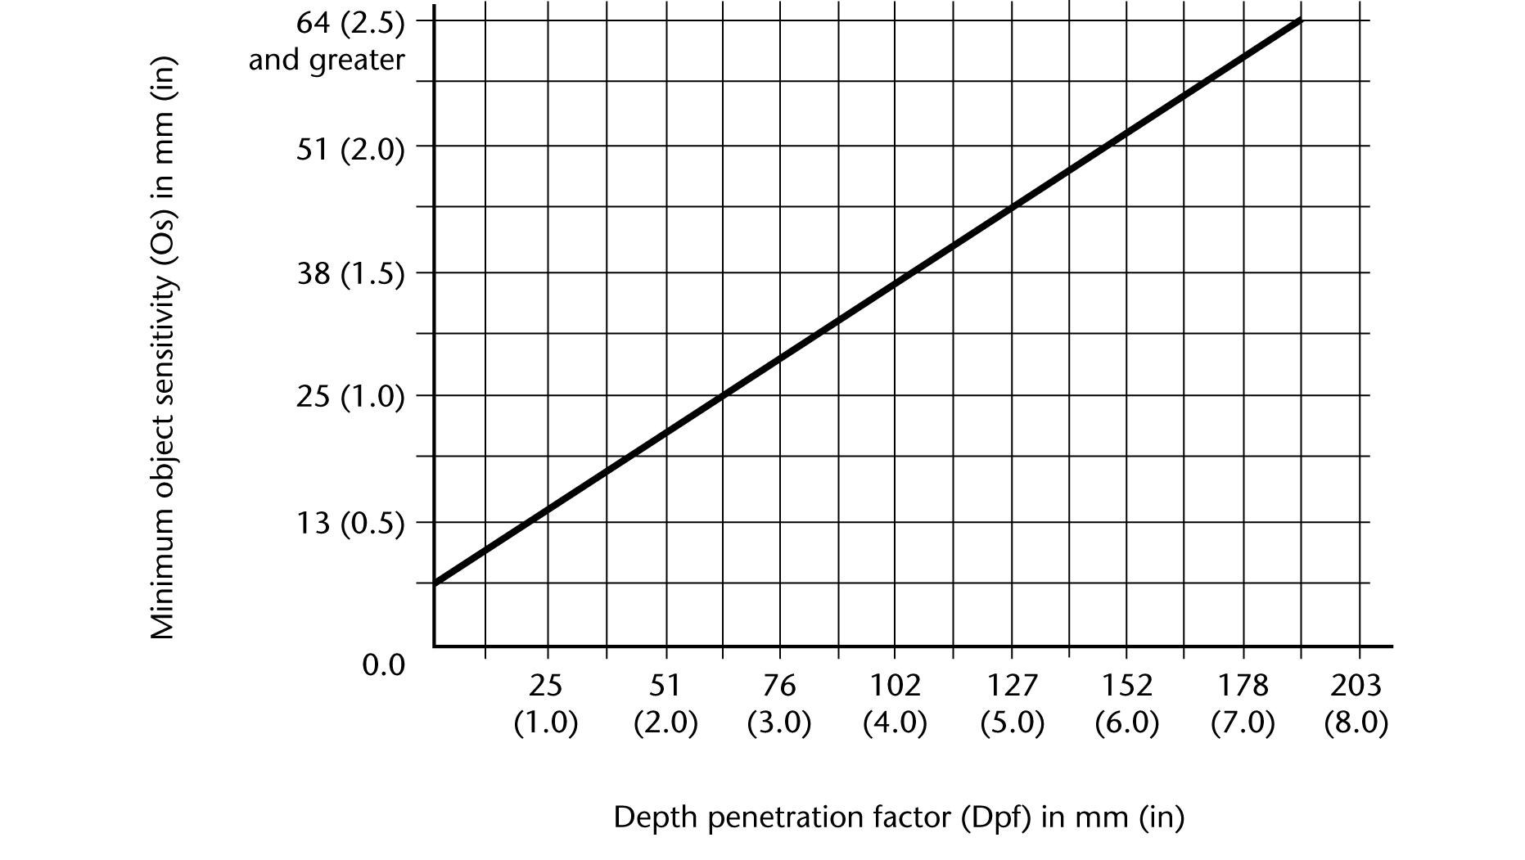
NOTE 1 – (CA/USA) For safety scanners, for further guidance about reference boundaries and resolution, see the manufacturer’s information for use.
NOTE 2 – (CA/USA) Do NOT extrapolate the graph. The Dpf graph and formula may be used in Canada and USA, so long as the Os is not greater than 64 mm (2.5 in). If the Os is greater than 64mm (2.5 in) for an application where personnel are reaching through the detection field, then the Dpf / C is 900 mm (36 in) or more.
NOTE 3 – (CA/USA) ISO 13855 sets a maximum 40mm Os for vertical point of operation safeguarding applications.

ESPE – horizontal detection field, see SPE horizontal detection field X.X

ESPE – reaching over
When it is possible to Reach OVER or UNDER rather than through the ESPE, the LARGER of the two dimensions Dpf or Reach from the tables below shall be used.
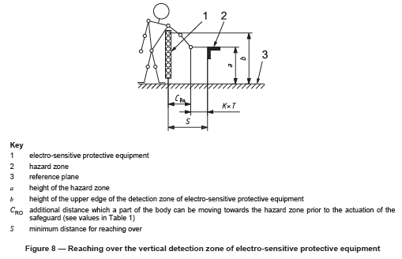
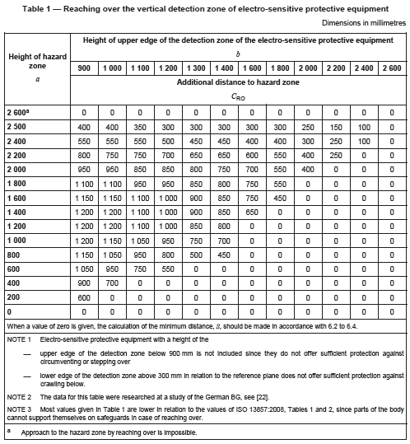
NOTE: The above table provides the horizontal distance, while the standard discusses the absolute distance (regardless of angle) from the intrusion to the hazard.

ESPE – reaching under
With a 300 mm (12 in) bottom opening distance, there shall be no hazard within 1100 mm of the bottom of the ESPE. If an operator can access a hazard, then an opening less than 300 mm (12 in) shall be provided.
The table below provides guidance on distance to hazards and height of the ESPE’s lowest active beam as measured from the adjacent standing surface.

Opening Under a ESPE e mm (in) | Safety Distance Sr mm (in)
Smallest Dimension
0 (0 ) < e ≤ 60 ( 2.4 ) | A portion of a foot | ≥ 180 (7.1)
60 (2.4) < e < 300 (12.0 ) | Up to the knee | ≥ 650 (26.0)
e = 300 (12 ) | Whole Leg Possible | 1100 (43 in)
Over 300 | Not Allowed unless additional protective measures are provided.

SPE (e.g., safety mat, safety scanner, light curtains, safety beams)– horizontal detection field
Depth of field:
Depth of field is the length of the sensing field in the direction of travel toward the hazard. It may differ from the Dpf as its minimum dimension must discourage attempts to stride over the detection field
Detection/ Sensing Field Height
The height of the detection field above the adjacent standing surface of the approaching individual.
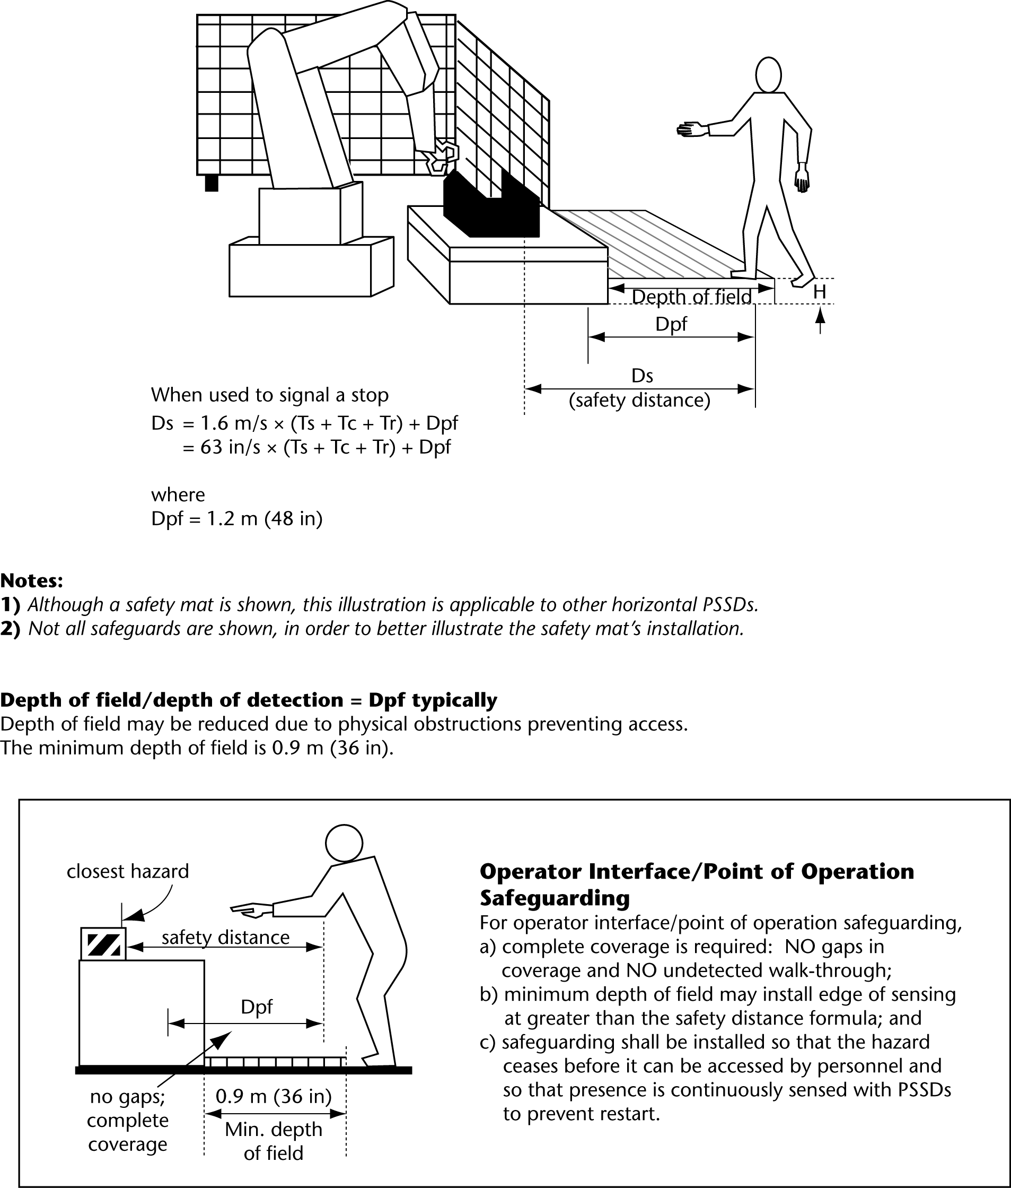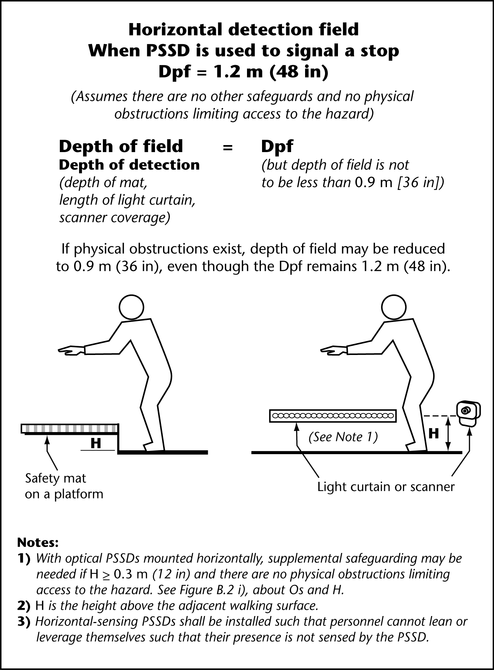
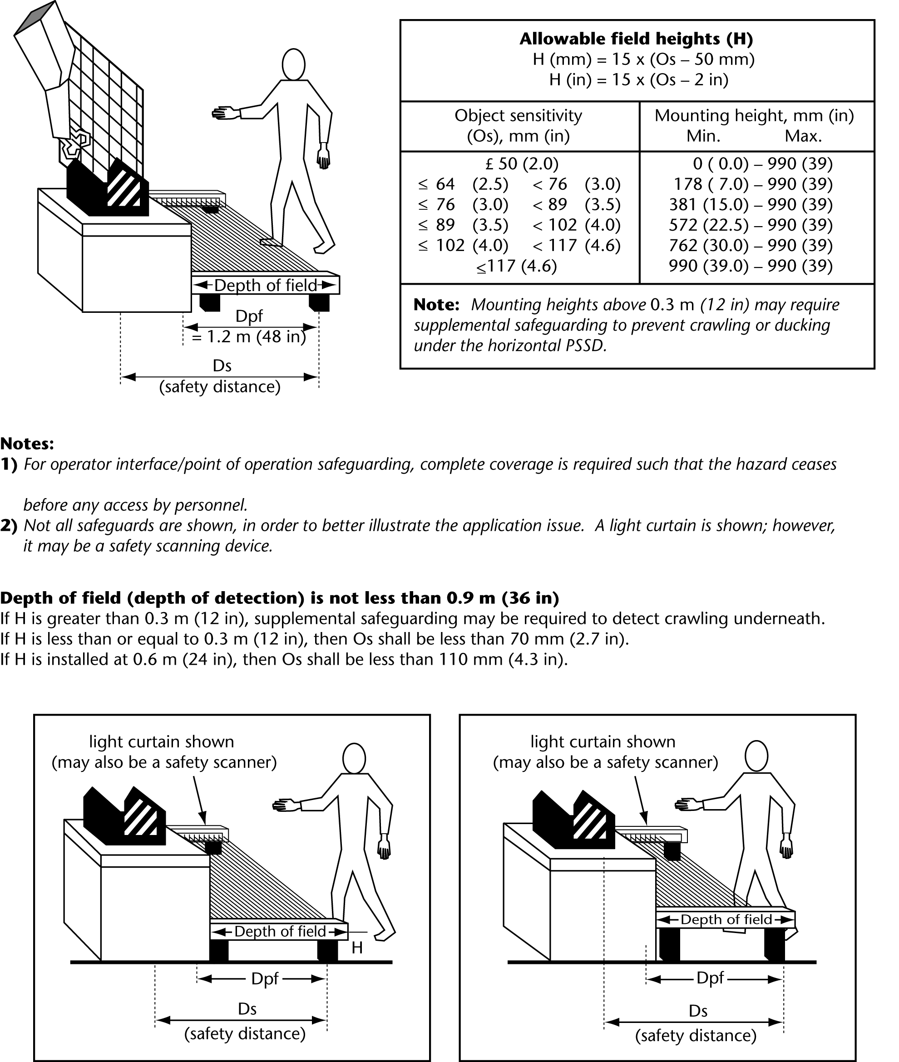

Change to graph. 990 is incorrect. Needs to be 1 meter.
shall require

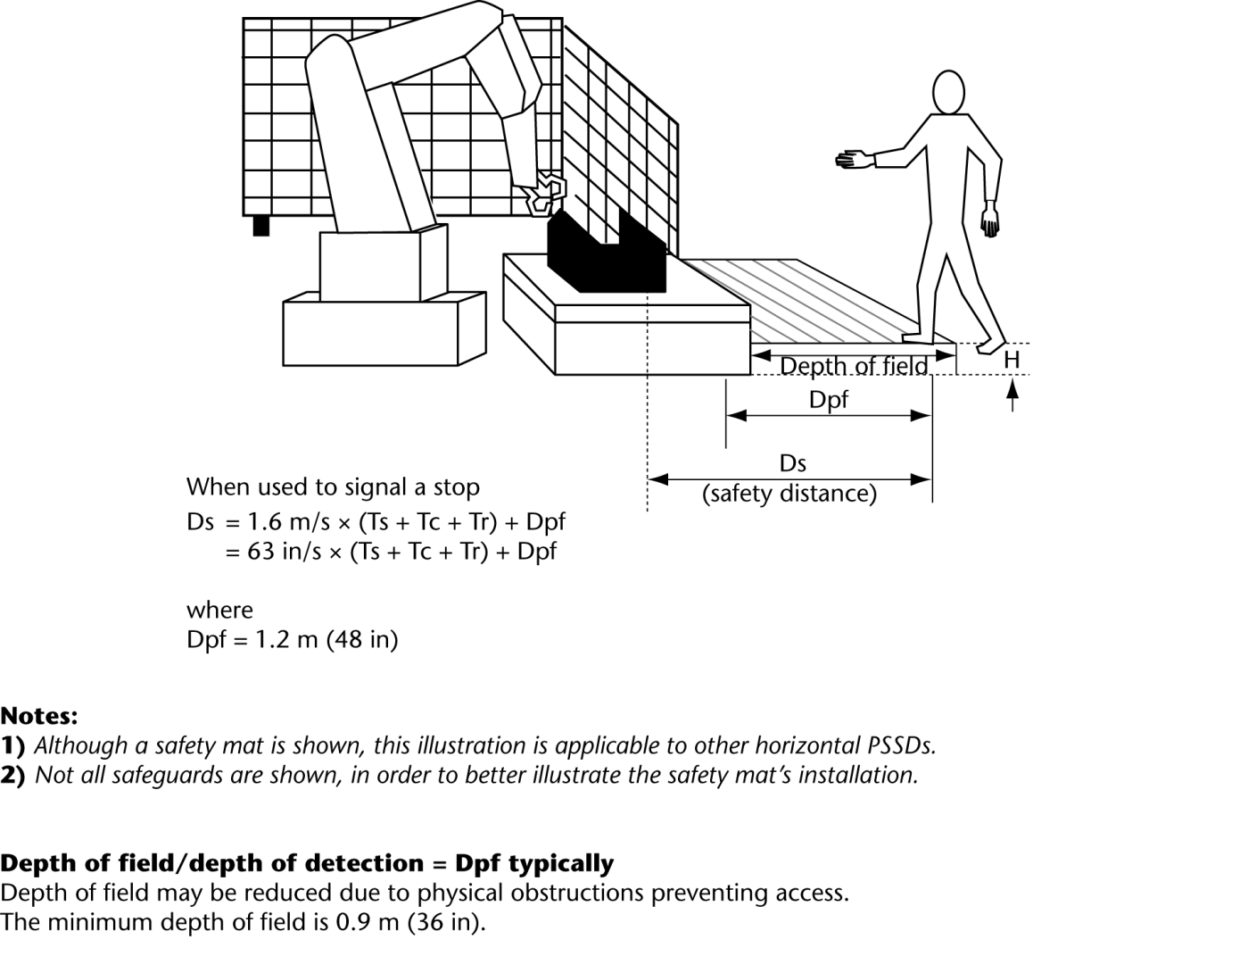

If the length of the slot opening is ≤ 65 mm, the thumb will act as a stop and the safety distance can be reduced to 200 mm. Reference ISO 13857.
If the length of the slot opening is ≤ 65 mm, the thumb will act as a stop and the safety distance can be reduced to 200 mm. Reference ISO 13857. Per ISO 13857, 850 mm (33 in) is considered the standard arm reach, while ANSI and CSA consider the arm reach to be 915 mm (36 in).
ISO 10218 clause X.X, note states that the K is 1600. For other applications, see ISO 13855 and the applicable C (machine specific) standards.

